

**A Project Report**

On

**Project Title: Unveiling Mental Health Signals**

submitted as partial fulfillment for the award of

**BACHELOR OF TECHNOLOGY**

**DEGREE**

SESSION 2024-25

in

**Computer Science & Engineering (AI&ML)**

By

Tushar Bhatnagar (2200291539006)

Saloni Jain (2100291530047)

Nitin Gupta (2200291539004)

**Under the supervision of**

Dr. Richa Singh

**KIET Group of Institutions, Ghaziabad**

Affiliated to

**Dr. A.P.J. Abdul Kalam Technical University, Lucknow**

(Formerly UPTU)

**May 2025**

**DECLARATION**

We hereby declare that this submission is our own work and that, to the best of our knowledge and belief, it contains no material previously published or written by another person nor material which to a substantial extent has been accepted for the award of any other degree or diploma of the university or other institute of higher learning, except where due acknowledgment has been made in the text.

**Signature Signature**

**Name: Name:**

**Roll No.: Roll No.:**

**Date: Date:**

**Signature**

**Name:**

**Roll No.:**

**Date:**

## CERTIFICATE

This is to certify that Project Report entitled **“Unveiling Mental Health Signals”** which is submitted by Tushar Bhatnagar(2200291539006), Saloni Jain (2100291530047), Nitin Gupta(2200291539004) in partial fulfillment of the requirement for the award of degree B. Tech. in Department of CSE(AIML) of Dr. A.P.J. Abdul Kalam Technical University, Lucknow is a record of the candidates own work carried out by them under my supervision. The matter embodied in this report is original and has not been submitted for the award of any other degree.

**Dr. Richa Singh Dr. Rekha Kashyap**

**(Assistant Professor) (Dean CSE-AI & CSE-AI&ML)**

**Date:**

**ACKNOWLEDGEMENT**

It gives us a great sense of pleasure to present the report on the B. Tech Project undertaken during B. Tech. Final Year. We owe special debt of gratitude to Dr. Richa Singh, Department of CSE(AIML), KIET, Ghaziabad, for her constant support and guidance throughout the course of our work. Her sincerity, thoroughness and perseverance have been a constant source of inspiration for us. It is only her cognizant efforts that our endeavors have seen light of the day.

We also take the opportunity to acknowledge the contribution of Dr. Rekha Kashyap, Dean of Computer Science & Engineering (AI) & Computer Science & Engineering (AI&ML), KIET, and Ghaziabad, for her full support and assistance during the development of the project. We also do not like to miss the opportunity to acknowledge the contribution of all the faculty members of the department for their kind assistance and cooperation during the development of our project.

We also do not like to miss the opportunity to acknowledge the contribution of all faculty members of the department for their kind assistance and cooperation during the development of our project. Last but not the least, we acknowledge our friends for their contribution to the completion of the project.

Date:

Signature:

Name :

Roll No.:

Date:

Signature:

Name :

Roll No.:

Date:

Signature:

Name :

Roll No.:

**ABSTRACT**

Mental health has emerged as a pressing concern in the modern, technology-driven world. With the widespread use of social media and digital communication, young individuals are increasingly exposed to unchecked and potentially harmful content, which can adversely affect their psychological well-being. This project, titled *Unveiling Mental Health Signals Using Machine Learning and Deep Learning Techniques*, aims to identify early indicators of mental health challenges by analysing user-generated content such as social media posts, anonymous messages, and behavioural patterns.

By utilizing cutting-edge Natural Language Processing (NLP) techniques and classification models—including transformer-based architectures like BERT—we detect emotional states linked to stress, anxiety, and depressive symptoms. To support users further, the system incorporates a sentiment-aware music recommendation module and an interactive chatbot that facilitates empathetic communication and motivational feedback.

This integrated framework is a step toward building a safe, responsive digital environment that encourages emotional resilience. While it is not a substitute for clinical intervention, the system offers an accessible, scalable, and non-invasive tool for promoting mental wellness. Its potential applications span real-time mental health tracking, digital self-care platforms, and supplementary tools for therapists and healthcare providers.

|  |  |  |  |
| --- | --- | --- | --- |
| **TABLE OF CONTENTS** | **Page No.** | | |
| DECLARATION…………………………………………………...…………………. | ii | | |
| CERTIFICATE…………………………………………………….…………………. | iii | | |
| ACKNOWLEDGEMENTS………………………………………….………………... | iv | | |
| ABSTRACT………………………………………………………………………….... | v | | |
| LIST OF FIGURES………………………………………………………………….... | viii | | |
| LIST OF TABLES…………………………………………………………….………. | ix | | |
| LIST OF ABBREVIATIONS………………………………………………...………... | x | | |
| CHAPTER 1 (INTRODUCTION)……………………………………...……………... | 11-16 | | |
| * 1. Background……………………………………………….……………………....   2. Problem Statement………………………………………………………………… | 11  12 | | |
| 1.3. Objective ……………….……………………………………….…….…………...  1.4. Project Aim …………………………………………………...…………………...  1.5. Scope of the Project………………………………………………………………...  1.6. Motivation.………………………………………………………………………...  1.7. Significance………………………………………………………………………. | 13  13  14  15  16 | | |
| CHAPTER 2 (LITERATURE RIVIEW) ………………………………….…………... | 17-26 | | |
| 2.1. General……………………………………………………………………………. | 17 | | |
| 2.2. Mental Health Detection using Machine Learning…………………………………  2.3. Deep Learning Approaches for Mental Health Prediction…………………………  2.4. Sentiment Analysis in Mental Health Applications……………………………….  2.5. Music Recommendation and Emotional Well-being………………………………  2.6. Chatbot Integration in Mental Health Support…………………………………….  2.7. Summary of Key Insights………………………………………………………….  2.8. Research Gap……………………………………………………………………… | 17  18  19  20  24  25  26 | | |
|  |  | | |
| |  |  | | --- | --- | | CHAPTER 3 (PROPOSED METHODOLOGY) ………………………….……………  3.1. System Overview……………………………………………………………………  3.2. BERT Model Architecture………………………………………………………….  3.2. Technologies Used………………………………………………………………….  3.3. System Architecture…………………………………………………….………….  3.4. Key Functional Components……………………………………………………….  3.5. Deployment Details……………………………………………………………........  3.6. Security & Privacy Measures………………………………………………………. |  | | CHAPTER 4 (IMPLEMENTATION) ……………………………………….………….  4.1. Data Collection………………………………………………………………………  4.1.1. Open-Source Datasets………………………………………………………...  4.1.2. Social Media Data…………………………………………………………….  4.1.3. Data Annotation………………………………………………………………  4.2. Data Preprocessing………………………………………………………………….  4.2.1. Text Cleaning…………………………………………………………………  4.2.2. Tokenization & Lemmatization…………………………………………. …..  4.2.3. Stopwords Removal………………………………………………………….  4.2.4. Handling Imbalanced Data…………………………………………………...  4.2.5. Feature Extraction………………………………………………………........  4.2.6. Sentiment Scoring…………………………………………...……………….  4.3. Learning Models………………………………………………………………........  4.3.1. Machine Learning Models………………………………….……………….  4.3.2. Deep Learning Models……………………………………………………….  4.3.3. Model Optimization………………………………………………………….  4.4. Evolution Metrics…………...……………………………………………………….  4.4.1. Accuracy………………………………………………………………………  4.4.2. Precision, Recall & F1-Score…………………………………………….......  4.4.3. AUC-ROC (Area Under the Receiver Operating Characteristic Curve) …….  4.4.4. Confusion Matrix…………………………………………………………….  4.5. Ethical Considerations………………………………………………………………  4.5.1. Data Privacy………………………………………………………………….  4.5.2. Bias Mitigation……………………………………………………………….  4.5.3. Responsible AI Use………………………………………………………….  4.5.4. Ethical Deployment………………………………………………………….  CHAPTER 5 (RESULTS AND DISCUSSION) …………………...…………………...  5.1. Dataset……………………………………………………………………………….  5.3. Result………………………………………………………………………………...  5.2. Discussion…………………………………………………………………………… | 4 | | CHAPTER 6 (CONCLUSIONS AND FUTURE SCOPE) …………………………….  6.1. Conclusion………………………………………………………………………….  6.2. Key Contributions………………………………………………………………….  6.3. Future Scope……………………………………………………………………….  6.3.1. Real-Time Social Media Monitoring………………………………….…......  6.3.2. Multimodal Emotion Detection…………………………………………........  6.3.3. Personalized Recommendations…………………………………………….  6.3.4. Integration with Mental Health Professionals……………………………….  6.3.5. Enhanced Chatbot Intelligence……………………………………………….  6.3.6. Privacy & Security Enhancements………………….……………………….  6.3.7. Explainable AI (XAI) Integration……………………………………………. | 5 | | REFERENCES…………………………………………………………………………. | 5 | | APPENDEX……………………………….…………………………………………… | 5 | | | 27-36  27  27  31  32  34  35  35  37-  37  37  37  37  37  37  38  38  38  38  38  38  39  40  41  41  42  42  42  42  44  44  45  45  45  46-52  46  50  58  61-64  61  62  63  63  63  63  63  64  64  64  65-68  69-73 |

**LIST OF FIGURES**

|  |  |  |
| --- | --- | --- |
| **Figure No.** | **Description** | **Page No.** |
| 2.1 | Sentiment Analysis | 20 |
| 2.2 | Music Recommendation System Architecture | 23 |
| 3.1 | BERT Model Architecture | 28 |
| 3.2 | BERT Model Architecture Flow Diagram | 30 |
| 3.2 | System Architecture | 33 |
| 4.1 | Data Preprocessing Workflow | 38 |
| 4.2 | Machine Model Vs. Deep Learning | 41 |
| 4.3 | Confusion Matrix | 44 |
| 5.1 | Unveiling Mental Health Signals Dashboard | 50 |
| 5.2 | Dashboard Dark Mode | 51 |
| 5.3 | Neutral Sentiment Prediction | 52 |
| 5.4 | Negative Sentiment Prediction | 52 |
| 5.5 | Positive Sentiment Prediction | 53 |
| 5.6 | Recommendation of Therapist near location | 54 |
| 5.7 | Recommendation of Articles | 55 |
| 5.8 | Recommendation of Music | 55 |
| 5.9 | Positive Sentiment Prediction through Emoji’s | 56 |
| 5.10 | Negative Sentiment Prediction through Emoji’s | 57 |
| 5.11 | Neutral Sentiment Prediction through Emoji’s | 58 |

**LIST OF TABLES**

|  |  |  |
| --- | --- | --- |
| **Table. No.** | **Description** | **Page No.** |
| 2.1 | Sentiment-Based Music Mapping Using Spotify API | 22 |
| 3.1 | Frontend Technologies | 31 |
| 3.2 | Backend Technologies | 31 |
| 3.3 | Machine Learning Technologies | 31 |
| 5.1 | Sentiment Mapping for This Project | 47 |
| 5.2 | Mental Health Twitter Dataset | 48 |

**CHAPTER 1**

**INTRODUCTION**

**1.1 Overview**

Mental health is a cornerstone of human well-being, shaping how individuals think, feel, relate to others, and cope with life’s challenges. In recent years, mental health conditions such as anxiety, depression, and suicidal ideation have witnessed a troubling rise, particularly among adolescents and young adults. According to the World Health Organization (WHO), over 264 million people globally suffer from depression, making it one of the leading causes of disability and loss of productivity [1].

The digital age has brought both connection and chaos. While social media platforms like Instagram, Twitter, TikTok, and Facebook enable communication and self-expression, they also introduce unprecedented exposure to harmful content, cyberbullying, social comparison, and emotional triggers. For vulnerable individuals—especially teens—this environment can accelerate psychological distress. As users engage more frequently with curated online personas and controversial or sensational content, they may internalize negative thoughts, leading to emotional instability.

Recent academic and governmental investigations highlight the severity of this crisis. A notable example is the 2021 U.S. Senate hearing where testimony from a former Facebook employee, Frances Haugen, revealed that internal research had confirmed Instagram’s harmful impact on teenage mental health, particularly among girls. The issue was further amplified during this hearing as concerns were raised about multiple social media platforms including Facebook, TikTok, and Twitter, all contributing to rising mental health problems in youth [2]. These findings emphasized how algorithmic amplification of harmful content, such as idealized body images or emotionally charged posts, contributes to rising anxiety, depression, and body image issues.

Additionally, the global COVID-19 pandemic acted as a catalyst, further amplifying feelings of isolation, loneliness, and digital dependency. As schools and colleges shifted to remote models, many young people turned to online platforms for social engagement—often without proper emotional regulation or support systems in place. Reports from organizations like UNICEF and the CDC noted increased rates of depressive symptoms, insomnia, and suicidal thoughts in students during prolonged lockdown periods [3].

Given the vast volume of user-generated content now available through platforms such as Reddit, Twitter, and mental health forums, there exists an opportunity to extract meaningful insights using artificial intelligence. These digital footprints—text posts, chats, comments, and reactions—can reveal emotional cues and behavioural patterns that are often invisible in clinical assessments. However, detecting these signals manually is impractical due to the scale and complexity of data.

This growing mental health crisis calls for intelligent, non-invasive, and scalable digital tools. Automated systems driven by Machine Learning (ML) and Natural Language Processing (NLP) offer the ability to detect emotional distress through textual analysis. These systems can act as early warning indicators and provide timely, personalized support, especially in environments where mental health services are limited or stigmatized.

Our project addresses this need by designing an AI-based solution capable of identifying mental health signals in user text and responding with emotion-aligned interventions such as motivational conversations and therapeutic music recommendations. By combining deep learning models, real-time sentiment classification, and a user-centric design, the system strives to build a safer digital environment that promotes mental resilience and emotional awareness.

**1.2 Problem Statement**

Despite growing awareness around mental health, there remains a critical lack of proactive and accessible tools capable of identifying emotional distress in real time. Many individuals experience mental health challenges such as anxiety, depression, and emotional exhaustion without openly expressing their struggles due to stigma, fear of judgment, or lack of self-awareness. Often, signs of deteriorating mental well-being are embedded subtly in day-to-day communication—appearing as linguistic patterns, tone shifts, or behavioural changes in text-based interactions.

Current support systems, including professional counselling and self-reporting tools, are either limited by accessibility or dependent on user initiation. As a result, countless individuals fall through the cracks, receiving no intervention until their mental health has significantly deteriorated.

There is a strong need for an intelligent, non-intrusive system that can automatically analyse user-generated text—such as social media posts, messages, or journal entries—and accurately detect early warning signs of psychological distress. Such a system should not only identify potential mental health issues but also respond with emotionally appropriate resources such as music therapy, motivational support, or chatbot-based interaction. An integrated AI solution that blends sentiment analysis, deep learning models, and personalized recommendations can bridge this gap by offering scalable, real-time mental health assistance that empowers users to take early action toward their well-being.

**1.3 Objectives**

* To develop an AI-powered system capable of detecting signs of mental health conditions—such as stress, anxiety, and depression—from user-generated textual data.
* To evaluate the psychological impact of harmful or triggering content on social media platforms and assess its role in emotional decline.
* To perform sentiment classification of text inputs into three distinct emotional categories: Positive (POS), Neutral (NEU), and Negative (NEG), using transformer-based deep learning models.
* To design and integrate a personalized music recommendation engine that aligns audio suggestions with the user's detected emotional state.
* To enhance model accuracy and generalizability through effective Natural Language Processing (NLP) techniques and feature engineering strategies, including tokenization, lemmatization, and contextual embeddings.

**1.4 Project Aim**

The central aim of this project is to design and implement an AI-driven platform that enables the early detection and support of mental health conditions by leveraging textual data shared by users through social media posts, messages, or online interactions. The system aspires to achieve the following:

* Detect and predict emotional distress and psychological conditions—such as depression, anxiety, and stress—by analysing users' language patterns and behavioural signals present in textual content.
* Perform sentiment analysis to classify user input into emotional categories: Positive, Neutral, or Negative, using state-of-the-art deep learning models like BERT.
* Deliver personalized mental health support by recommending curated music playlists that align with the user's emotional state and promote psychological relief.
* Incorporate an intelligent chatbot interface that facilitates safe, empathetic, and engaging conversations, offering motivational support and resources to users in need.

**1.5 Scope of the Project**

The primary objective of this project is to analyse unstructured textual data to detect and interpret mental health indicators by employing advanced techniques from both Machine Learning (ML) and Deep Learning (DL). By focusing on text data sourced from social media platforms and other online forums, the project aims to identify patterns and signals that may indicate mental health concerns such as anxiety, depression, stress, or suicidal tendencies.

The scope of this work encompasses the following key components:

* **Development of a Comprehensive Data Processing Pipeline:** Establishing a systematic and efficient data pipeline that handles the entire lifecycle of raw text data. This includes data acquisition, cleaning, normalization, tokenization, and transformation into suitable feature representations. The pipeline will ensure that data quality is maintained, and the inputs are optimized for subsequent analysis.
* **Implementation and Evaluation of Various Machine Learning and Deep Learning Models:** Applying a range of ML and DL algorithms tailored for classification tasks to accurately detect sentiments and mental health states from text. This involves comparing traditional models like Support Vector Machines, Random Forests, and Logistic Regression with deep neural architectures such as LSTMs, CNNs, and transformer-based models to find the best performing approach.
* **Creation of a Sentiment-Based Music Recommendation System:** Designing a system that integrates sentiment analysis results with predefined rules to recommend appropriate music tracks. This recommendation engine will offer mood-enhancing or calming music depending on the user's detected emotional and mental health status, thereby providing a supportive tool for mental well-being.
* **Development of a Conversational Chatbot for User Support:** Building a user-friendly chatbot capable of holding empathetic and meaningful conversations. The chatbot will provide emotional support by engaging users in supportive dialogues and offering guidance or resources when signs of mental distress are detected.
* **Performance Measurement and Validation:** Conducting rigorous testing and validation of the implemented models and systems using standard classification metrics such as accuracy, precision, recall, and F1-score. This will ensure the reliability and robustness of the mental health detection and recommendation functionalities.

**1.6 Motivation**

* Traditional methods for identifying mental health issues predominantly depend on clinical evaluations and self-administered questionnaires. While these approaches have been the cornerstone of mental health diagnosis, they come with significant challenges. Often, individuals may feel reluctant to disclose their true feelings or symptoms due to social stigma, fear of being judged, or cultural inhibitions. This reluctance can lead to underreporting and delays in seeking professional assistance, which in turn hampers early diagnosis and timely intervention. Additionally, these traditional methods typically require face-to-face interactions with healthcare professionals, making continuous monitoring difficult and sometimes inaccessible, especially in remote or underserved areas.
* On the other hand, the digital age has ushered in a new era where individuals express much of their thoughts, feelings, and daily experiences through online platforms such as social media, chat applications, and forums. These digital footprints provide a rich, real-time source of data that reflects users' emotional and mental states. Unlike traditional assessments, this data is abundant, continuously generated, and captures spontaneous expressions, making it an invaluable resource for mental health monitoring.
* The rapid advancements in Artificial Intelligence (AI), particularly in Machine Learning (ML) and Deep Learning (DL), have unlocked the potential to process and analyse these vast amounts of textual data efficiently. These technologies enable the detection of subtle linguistic and behavioural patterns that may signal emotional distress or emerging mental health conditions. By leveraging AI-driven analysis of everyday online interactions, it becomes feasible to identify early warning signs that might otherwise go unnoticed in conventional clinical settings.
* This capability opens the door to proactive mental health support—providing timely alerts and personalized interventions that could mitigate the progression of mental illnesses. Ultimately, integrating AI techniques with digital behavioural data offers a promising pathway to bridge the gap between mental health needs and accessible care, helping to reduce the burden of mental disorders and improving overall well-being in society.

**1.7 Significance**

* The development of this AI-driven system holds considerable significance in the realm of mental health care by offering innovative, accessible, and scalable solutions for emotional support. By leveraging machine learning and deep learning techniques to analyse textual data, this system can serve as the foundation for mobile or web-based applications that provide users with timely, personalized assistance. Such platforms can deliver real-time emotional support through tailored music recommendations, empathetic chatbot conversations, and early detection of mental health concerns.
* This approach can greatly enhance mental well-being by bridging the gap between individuals and professional help, especially for those who may be hesitant to seek traditional therapy due to stigma or logistical barriers. Furthermore, the system’s ability to continuously monitor users’ mental states through their digital interactions offers a proactive model of mental health care, allowing for earlier intervention and ongoing support.
* By empowering users with accessible, non-intrusive, and personalized mental health tools, this project contributes to destigmatizing mental health issues and promotes greater awareness and self-care. Ultimately, the scalable nature of AI-based mental health solutions can extend support to larger populations, including underserved communities, thereby making mental health resources more inclusive and widespread.

**CHAPTER 2**

**LITERATURE REVIEW**

**2.1 Overview**

Over the last ten years, the use of computational techniques to detect mental health conditions has become an increasingly important area of research. While traditional clinical assessments such as interviews and questionnaires remain fundamental, they are often limited by factors such as delayed diagnosis, subjectivity, and the stigma associated with seeking help. In response, data-driven methods powered by Artificial Intelligence (AI) and Machine Learning (ML) have emerged as powerful complements to conventional approaches. These techniques focus on analysing large volumes of digital behavioural data—such as text, speech, and interaction patterns—to uncover subtle indicators of mental health issues.

Natural Language Processing (NLP), a branch of AI concerned with understanding and processing human language, plays a critical role in this domain. By examining linguistic features, sentiment, and context in user-generated text, NLP-based systems can identify signs of depression, anxiety, stress, and other psychological conditions. Additionally, AI-driven recommendation systems are being integrated to offer personalized support resources, including music recommendations and chatbot interactions, aimed at improving mental wellness.

This chapter provides an overview of the significant advancements and foundational research in the field, highlighting how computational models and AI technologies are applied to detect mental health signals and provide supportive interventions. The review centres on key studies that demonstrate the evolving synergy between mental health analytics, NLP techniques, and intelligent recommendation systems, which collectively form the backbone of the project’s approach.

**2.2 Mental Health Detection using Machine Learning**

A growing body of research has demonstrated the effectiveness of machine learning techniques in identifying mental health signals from textual data sourced primarily from social media platforms. These models analyse patterns in language use, sentiment, and behavioural markers to detect signs of psychological conditions such as depression, anxiety, and suicidal ideation.

For example, Resnik et al. (2015) conducted a pioneering study where they employed Support Vector Machines (SVM) and Logistic Regression classifiers to analyse Reddit posts. Their work showed that specific linguistic features—such as word choice, syntax, and semantic context—can serve as reliable indicators of depressive symptoms. By training models on annotated data, they were able to classify users at risk of depression with a notable degree of accuracy, highlighting the predictive power of machine learning in this domain.

Similarly, Coppersmith et al. (2018) explored mental health detection on Twitter by applying Random Forest and Decision Tree algorithms to large datasets. Their research emphasized that even relatively straightforward machine learning models could successfully capture subtle mental health cues embedded in text. Key features included sentiment polarity (positive or negative tone), the frequency of particular words or phrases, and emotionally charged vocabulary. These indicators helped the models identify users expressing suicidal thoughts or depressive states, underscoring the potential of such automated systems to support early detection efforts.

Together, these studies illustrate how classical machine learning approaches, when combined with carefully engineered linguistic features, can provide scalable and efficient tools for mental health screening using everyday digital communications.

**2.3 Deep Learning Approaches for Mental Health Prediction**

Deep learning techniques have significantly advanced the field of mental health prediction by enabling models to capture intricate and nuanced patterns within large-scale textual data. Unlike traditional machine learning methods that often require manual feature engineering, deep learning models can automatically learn hierarchical representations of text, which improves their ability to understand context, semantics, and subtle emotional cues.

One notable approach involves Convolutional Neural Networks (CNNs), which were effectively applied by Kim et al. (2016) to sentence classification tasks. CNNs, originally developed for image recognition, have been adapted to analyse short text snippets by identifying key local features, such as important word sequences or phrases that may indicate depressive symptoms. Their study revealed that CNNs can achieve robust performance in detecting mental health-related content from brief textual inputs.

Recurrent Neural Networks (RNNs), especially Long Short-Term Memory (LSTM) networks, have been widely used to process sequential data and maintain contextual dependencies over longer stretches of text. Orabi et al. (2018) leveraged LSTMs on Reddit posts, demonstrating that these models outperform traditional machine learning algorithms by better understanding the flow of language and emotional transitions within user-generated content. This capability is crucial when analysing posts where the meaning is influenced by the order and relationship between words or sentences.

More recently, transformer-based architectures like BERT (Bidirectional Encoder Representations from Transformers) have revolutionized natural language processing tasks. BERT’s bidirectional context understanding allows it to grasp the meaning of words based on their surrounding text, resulting in highly accurate predictions. Sun et al. (2019) fine-tuned BERT models specifically for sentiment and emotion classification related to mental health, achieving state-of-the-art results in identifying psychological distress signals from social media data. These transformer models continue to set new benchmarks, making them an essential tool for modern mental health detection systems.

**2.4 Sentiment Analysis in Mental Health Applications**

Sentiment analysis serves as a foundational technique in mental health research by helping to infer users’ emotional states through their textual expressions. By quantifying the polarity of language—whether positive, negative, or neutral—sentiment analysis provides valuable insights into psychological well-being and emotional fluctuations over time.

Popular sentiment analysis tools such as VADER (Valence Aware Dictionary and Sentiment Reasoner) and TextBlob have been widely used due to their effectiveness and ease of implementation. VADER is particularly suited for social media text, as it incorporates lexical features tailored to informal language, emoticons, and slang, enabling it to capture nuanced sentiment in short messages. TextBlob, on the other hand, offers a straightforward interface for polarity and subjectivity detection, making it a useful tool for preliminary sentiment classification tasks.

Research by Choudhury et al. (2013) highlighted the critical role of sentiment analysis in mental health monitoring. By analysing temporal changes in sentiment expressed through Twitter posts, their study was able to detect early signs of depression in users before clinical diagnosis. This work demonstrated that tracking shifts in emotional tone over time could serve as an early warning system for mental health issues, emphasizing the importance of integrating sentiment analysis with predictive models to achieve a comprehensive understanding of an individual’s mental state.

Overall, sentiment analysis not only aids in identifying emotional distress but also forms the basis for developing interventions and personalized recommendations, thereby enhancing the capacity of AI systems to support mental health care.

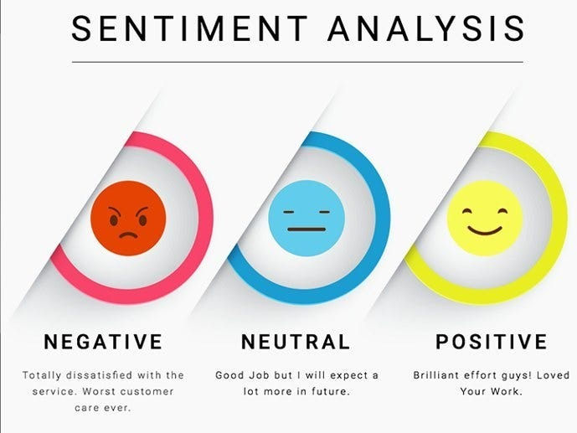

Fig.2.1: Sentiment Analysis

**2.5 Music Recommendation and Emotional Well-being**

Music has long been recognized for its therapeutic potential, playing a significant role in emotional regulation, stress reduction, and mental well-being. In recent years, researchers have explored the integration of emotion-aware music recommendation systems as a non-invasive method to support mental health. By tailoring music suggestions to match or influence a user’s mood, these systems aim to foster positive emotional shifts and improve psychological resilience.

Earlier studies, such as the work by Yang and Chen (2012), introduced the concept of emotion-based music recommendation. Their approach utilized mood states extracted from textual inputs to recommend music that aligned with or countered the user's emotional condition. The findings reinforced that emotionally congruent music—i.e., songs matching the listener’s mood—could help users feel understood and emotionally supported, while mood-enhancing tracks could alleviate negative feelings and promote relaxation.

Building on this foundation, modern AI-driven platforms have evolved to incorporate real-time sentiment analysis and user behaviour tracking for more dynamic personalization. In this project, we utilize the **Spotify Web API** to fetch music recommendations based on sentiment labels derived from user-generated text (e.g., social media posts, chat inputs). The sentiment classifier first detects whether a user is exhibiting **negative (NEG), neutral (NEU), or positive (POS)** emotional cues. Based on this classification, a curated playlist or a randomized set of songs is selected from predefined categories mapped to the respective mood state.

Spotify's robust API offers extensive metadata, including track energy, valence, tempo, and popularity—attributes that can be intelligently filtered to align with the user’s emotional state. For example:

* **Negative Sentiment**: The system recommends calming and instrumental music, such as **Rishab Rikhiram Sharma's Sitar compositions**, known for their therapeutic effect.
* **Neutral Sentiment**: Balanced, soft, or ambient tracks are selected to maintain emotional equilibrium.
* **Positive Sentiment**: Uplifting and energetic songs are recommended to amplify the user’s good mood.

By integrating Spotify’s real-time capabilities with emotion-aware filtering, the system enhances user engagement and offers a supportive environment for emotional self-care. This seamless fusion of mental health analytics and personalized music therapy demonstrates the potential of technology-assisted well-being tools in everyday life. The summary regarding sentiment-based music mapping using Spotify API is mentioned in Table 2.1. The table includes the sentiments.

This table outlines how the system personalizes music recommendations based on a user's emotional state, classified as Negative, Neutral, or Positive. By leveraging Spotify API’s audio features such as **valence** (musical positivity), **energy**, and **mode** (major/minor key), the system filters songs that align with the user’s mood to support emotional regulation.

* **Negative Sentiment (NEG):** Users feeling sad, anxious, or lonely are recommended calming and soothing tracks. Music with low valence and energy is preferred, often in minor keys, to reflect their mood and provide a sense of calm. Examples include instrumental genres and artists like *Rishab Rikhiram Sharma* or *Ludovico Einaudi*.
* **Neutral Sentiment (NEU):** For users in a balanced or contemplative state, the system suggests mellow genres like lo-fi beats or acoustic pop. These tracks maintain mid-range valence and energy to support reflective thinking. Artists such as *Lo-Fi Girl* and *John Mayer* are typically recommended.
* **Positive Sentiment (POS):** Happy or relaxed users receive upbeat and energetic music. Filters prioritize high valence and energy in major keys to enhance their mood further. Popular genres include pop, dance, and Bollywood party tracks by artists like *Arijit Singh* and *Taylor Swift*.

This emotion-aware mapping ensures that music recommendations are not only personalized but also therapeutically aligned with the user's current emotional needs.

**Table 2.1: Sentiment-Based Music Mapping Using Spotify API**

|  |  |  |  |  |
| --- | --- | --- | --- | --- |
| Sentiment | Emotion State | Music Type | Spotify API Filters Used | Example Artists / Genres |
| Negative (NEG) | Sad, Anxious, Lonely | Calming instrumental, ambient, classical | valence: 0.0–0.3, energy: 0.1–0.4, mode: minor | Rishab Rikhiram Sharma, Ludovico Einaudi, Sitar, Piano Chill |
| Neutral (NEU) | Balanced, Reflective | Soft pop, lo-fi beats, acoustic | valence: 0.4–0.6, energy: 0.3–0.6 | Lo-Fi Girl, John Mayer, Acoustic Chill |
| Positive (POS) | Happy, Excited, Relaxed | Uplifting pop, dance, upbeat Hindi/English songs | valence: 0.7–1.0, energy: 0.6–1.0, mode: major | Arijit Singh, Taylor Swift, Bollywood Party Hits |

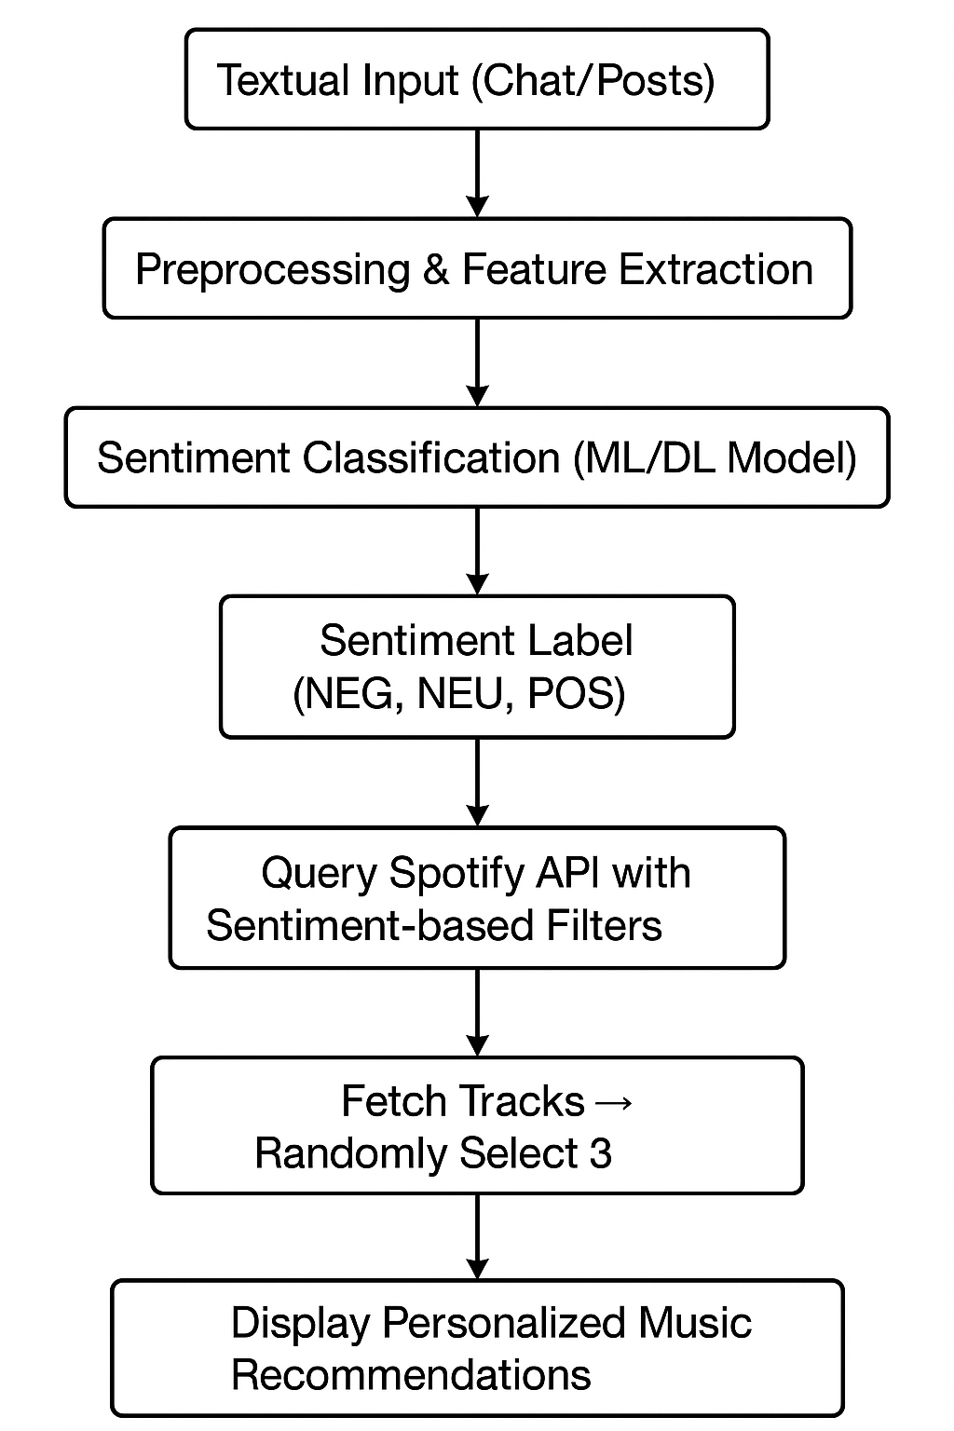

Figure 2.2: Music Recommendation System Architecture (Using Spotify API)

This flowchart presents the **end-to-end process** of a sentiment-driven music recommendation system:

1. **Textual Input (Chat/Posts):**  
   Users provide text-based inputs, such as social media posts or chat messages.
2. **Preprocessing & Feature Extraction:**  
   The raw text is cleaned and transformed into a structured format suitable for analysis using techniques like tokenization, lemmatization, and feature encoding (e.g., TF-IDF or embeddings).
3. **Sentiment Classification (ML/DL Model):**  
   A trained Machine Learning or Deep Learning model analyses the text to predict the user's sentiment.
4. **Sentiment Label (NEG, NEU, POS):**  
   Based on the model’s output, the user is tagged with a sentiment label—Negative (NEG), Neutral (NEU), or Positive (POS).
5. **Query Spotify API with Sentiment-based Filters:**  
   According to the sentiment, the system queries Spotify using filters like valence (mood), energy, and mode to find matching songs.
6. **Fetch Tracks → Randomly Select 3:**  
   The system retrieves relevant tracks from Spotify and randomly picks three to add variety.
7. **Display Personalized Music Recommendations:**  
   Finally, the selected songs are shown to the user as tailored music recommendations to enhance or stabilize their emotional state.

**2.6 Chatbot Integration in Mental Health Support**

In recent years, chatbots have emerged as powerful tools in the realm of mental health support, providing users with a confidential and judgment-free environment to share their thoughts and feelings. Unlike traditional human-to-human interactions, chatbots are accessible 24/7 and offer instant responses, making them an ideal solution for individuals who may hesitate to seek professional help due to stigma, fear, or lack of access.

Several mental health applications have successfully integrated AI-based conversational agents to guide users through therapeutic exercises and emotional check-ins. Popular examples include **Woebot**, **Wysa**, and **Replica**, each of which leverages artificial intelligence and natural language processing to simulate empathetic, context-aware dialogue. These tools are often designed around psychological frameworks such as **Cognitive Behavioural Therapy (CBT)**, **Dialectical Behaviour Therapy (DBT)**, and **Mindfulness-Based Stress Reduction (MBSR)**.

A notable study by **Fitzpatrick et al. (2017)** demonstrated that users who interacted regularly with a chatbot delivering CBT techniques reported a significant reduction in symptoms of depression and anxiety over a two-week period. These findings underscore the potential of AI-powered chat interfaces as low-cost, scalable interventions in mental health care.

In the context of this project, a chatbot serves as a virtual companion capable of engaging users in real-time, empathetic conversations. It not only responds to text inputs but also interprets the emotional tone behind the user's words using sentiment analysis techniques. Based on these insights, the chatbot can initiate comforting dialogues, suggest coping mechanisms, or redirect users to helpful resources such as calming music or emergency helplines.

Integrating a chatbot into the mental health detection system enhances the overall user experience by providing continuous emotional support. It transforms passive detection into active intervention, reinforcing the project's goal of fostering mental well-being through intelligent, responsive technology.

**2.7 Summary of Key Insights**

The literature reviewed in this chapter highlights several critical advancements and best practices at the intersection of mental health analysis and artificial intelligence:

* **Effectiveness of Traditional Machine Learning Models**: Classical machine learning algorithms such as Support Vector Machines (SVM) and Random Forest have shown strong performance in categorizing mental health signals when applied to well-structured and pre-processed textual datasets. Their simplicity and interpretability make them valuable for initial analysis stages.
* **Advantage of Deep Learning Architectures**: Models like Long Short-Term Memory (LSTM) networks and transformer-based architectures such as BERT have demonstrated superior capabilities in understanding contextual nuances and sequential dependencies in user-generated content. This results in more accurate and reliable detection of psychological conditions such as depression, anxiety, and suicidal ideation.
* **Role of Sentiment Analysis**: Sentiment analysis remains a fundamental component in mental health detection systems. By classifying emotional tone (positive, negative, or neutral), it provides essential features that can be used to infer users’ emotional states over time and flag concerning behavioural patterns.
* **Music Recommendation for Emotional Regulation**: Personalized music recommendations based on detected emotional states offer a non-invasive, engaging method for improving mental well-being. Emotion-aware music therapy enhances the overall user experience and contributes positively to mood stabilization.
* **Chatbot Integration for Scalable Support**: Conversational agents powered by AI can deliver immediate and empathetic responses, making them valuable tools in mental health interventions. They provide users with a supportive platform to express emotions, which might otherwise remain unshared, and can be designed to guide users through coping mechanisms or therapeutic dialogues.

Collectively, these insights form a strong foundation for building intelligent mental health support systems that combine prediction, personalization, and emotional engagement.

**2.8 Research Gap**

Despite the advancements in applying AI and machine learning techniques to mental health detection, several gaps remain that limit the overall efficacy, generalizability, and scalability of current solutions. Addressing these gaps is essential for building more robust and inclusive mental health support systems.

* **Need for Multi-Modal Approaches**: Most existing models rely primarily on textual data, which may not capture the full spectrum of an individual's emotional or psychological state. Future research should focus on developing multi-modal systems that integrate textual, behavioural, speech, and visual cues. This holistic approach can offer a more accurate and comprehensive assessment of mental health conditions.
* **Lack of Cultural and Linguistic Diversity in Datasets**: Many current models are trained on English-language datasets derived from specific demographic groups, leading to potential cultural and linguistic biases. There is a pressing need to develop and utilize datasets that are more representative of global populations to ensure fairness, accuracy, and applicability across different communities.
* **Limited Real-Time Monitoring Capabilities**: Most systems perform static analysis on historical data rather than offering continuous, real-time monitoring. Incorporating real-time data streams and feedback loops into mental health assessment tools can allow for timely interventions and better support in critical moments.

Bridging these research gaps will pave the way for next-generation mental health technologies that are more inclusive, dynamic, and effective in promoting emotional well-being.

**CHAPTER 3**

**PROPOSED METHODOLOGY**

**3.1 System Overview**

The proposed system is designed to analyse user-generated textual content—such as posts on social media platforms, chat messages, and interaction patterns—to detect and predict mental health states effectively. It is built on a modern, scalable architecture that combines a user-friendly web frontend with a robust backend powered by FastAPI. This backend seamlessly interacts with advanced machine learning models, notably BERT (Bidirectional Encoder Representations from Transformers), to perform precise sentiment analysis and mental health condition classification.

Upon classifying the sentiment of the input text, the system generates personalized recommendations, including carefully curated music tracks and motivational quotes, aimed at improving the user's emotional well-being. Additionally, an interactive chatbot interface is integrated to provide users with a safe and supportive environment where they can express their feelings and receive empathetic responses. This conversational feature enhances user engagement and promotes mental health awareness through ongoing dialogue and encouragement.

**3.2 BERT Model Architecture**

At the heart of our mental health signal detection system lies the BERT model, a cutting-edge transformer-based neural network developed by Google AI. BERT has revolutionized natural language processing by introducing bidirectional context understanding, which is crucial for tasks such as sentiment analysis, where the meaning of a sentence can depend heavily on the surrounding words.

**Overview of BERT Architecture:**

BERT is pre-trained on enormous text datasets, including the entirety of Wikipedia and the Book Corpus, through two key self-supervised learning objectives: Masked Language Modelling (MLM), where random words in a sentence are masked and predicted, and Next Sentence Prediction (NSP), which helps the model understand relationships between consecutive sentences. This pre-training allows BERT to learn rich language representations that can later be adapted to specific downstream tasks with relatively small amounts of task-specific data.

Unlike traditional models that process text sequentially, BERT uses a self-attention mechanism to simultaneously consider all words in a sentence. This enables it to build a deep contextual understanding, capturing nuances and relationships between tokens in both forward and backward directions.

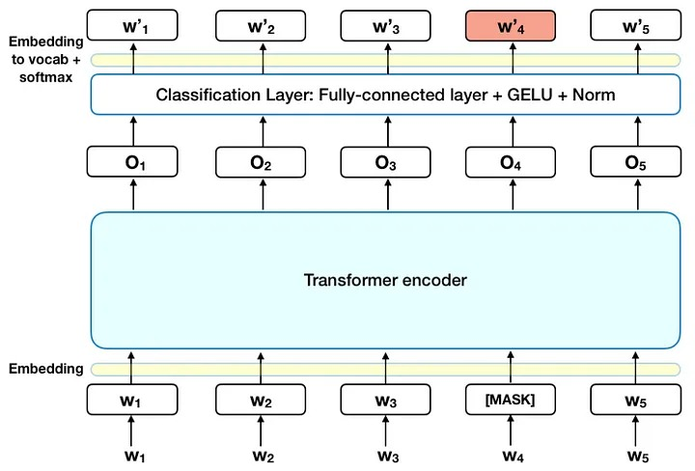

Fig. 4.1: BERT Model Architecture

**Input Representation:**

The input to BERT consists of three combined embeddings for each token:

* **Token Embeddings:** Represent the vocabulary tokens obtained from the WordPiece tokenizer, which splits words into subword units for better handling of rare or unknown words.
* **Segment Embeddings:** Used when the input includes sentence pairs, this embedding differentiates between Sentence A and Sentence B within the input sequence.
* **Position Embeddings:** Since transformers do not inherently understand token order, these embeddings encode the position of each token to maintain sequence information.

These embeddings are summed elementwise to form the final input representation fed into the transformer layers.

**Model Components:**

The BERT-Base variant employed here comprises 12 transformer layers. Each layer includes:

* **Multi-Head Self-Attention:** This mechanism allows the model to attend to different parts of the sentence simultaneously, capturing complex relationships between words at various positions.
* **Feedforward Neural Networks:** Fully connected layers apply nonlinear transformations to the attention outputs, enhancing the model’s expressive power.
* **Layer Normalization and Residual Connections:** These architectural elements improve training stability and help prevent vanishing gradients by allowing better flow of information across layers.

**Classification Using the [CLS] Token:**

Every input sequence is prepended with a special classification token, [CLS]. After processing through all transformer layers, the output corresponding to this token is considered a summary representation of the entire input sequence. This vector is then passed through a fully connected layer, followed by a softmax activation, to generate probabilities across three sentiment classes: Negative (NEG), Neutral (NEU), and Positive (POS).

**Regularization with Dropout:**

To reduce the risk of overfitting during training, a dropout layer is applied to the [CLS] token’s final representation before classification. Dropout randomly deactivates a fraction of neurons during training, encouraging the model to learn more robust features.

**BERT** **Architecture Flow Diagram:**

A simplified flow of the BERT architecture starts with input embeddings, which move through the multi-layer transformer encoder, producing contextualized token representations. The [CLS] token’s output is then fed to a classification head that outputs sentiment predictions.

**Advantages of Using BERT**

* **Enhanced Contextual Comprehension:** BERT’s bidirectional architecture enables it to analyze words in a sentence by considering both preceding and succeeding context. This capability allows the model to detect nuanced emotional and psychological indicators embedded in text, which are often missed by traditional models that read text only in one direction.
* **Robust Pre-Trained Language Knowledge:** Having been trained on large-scale datasets such as Wikipedia and BookCorpus, BERT carries extensive general language understanding. This pre-existing knowledge significantly reduces the need for large amounts of labelled data when adapting the model to specific tasks like mental health sentiment analysis, enabling more efficient and effective training.
* **Adaptability Through Fine-Tuning:** BERT’s design allows for straightforward fine-tuning on various downstream applications with minimal modifications to its core architecture. This flexibility makes it especially suitable for specialized tasks such as classifying sentiments related to mental health, as it can quickly adjust to new datasets and classification goals without retraining from scratch.

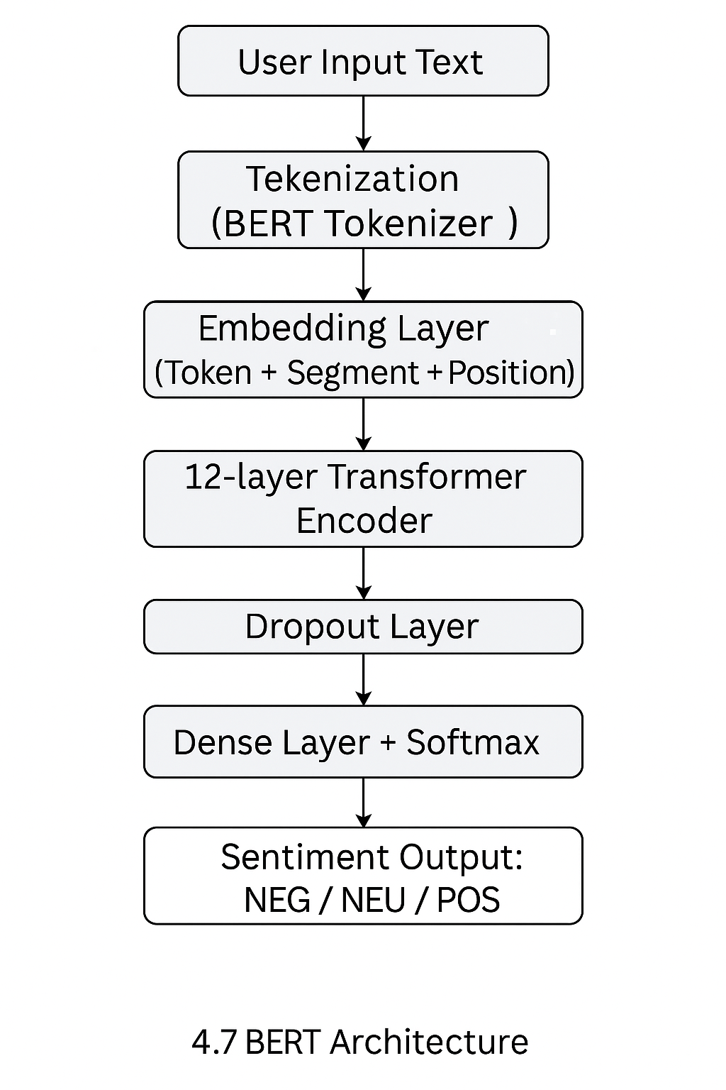

Fig. 3.1: BERT Architecture Flow Diagram

**3.2 Technologies Used**

**Table 3.1: Frontend Technologies**

|  |  |
| --- | --- |
| Technology | Description |
| React.js | JavaScript library for building interactive UIs. |
| Tailwind CSS | Utility-first CSS framework for responsive design. |
| HTML5 | Markup language for structuring web content. |
| CSS3 | Style sheet language for visual styling. |
| JavaScript | Scripting language for frontend logic and interactivity. |

**Table 3.2: Backend Technologies**

|  |  |
| --- | --- |
| Technology | Description |
| Python 3.11 | Programming language for model development and APIs. |
| FastAPI | High-performance Python web framework for building APIs. |
| BERT | Pre-trained Transformer model from Hugging Face for NLP tasks. |
| Scikit-learn | ML library is used for traditional classification models. |
| Pandas | Data manipulation and analysis library. |
| NumPy | Library for numerical computations and arrays. |
| Hugging Face Transformers | Library for implementing BERT and other NLP models. |

**Table 3.3: Machine Learning Technologies**

|  |  |
| --- | --- |
| Programming Language | Python |
| Natural Language Processing | NLTK, SpaCy, TextBlob, VADER, Hugging Face Transformers |
| Machine Learning & Deep Learning | Scikit-learn, TensorFlow/Keras, PyTorch |
| Data Handling | Pandas, NumPy |
| Visualization | Matplotlib, Seaborn |
| Web Scraping | BeautifulSoup, Tweepy (for Twitter API) |
| Deployment Framework | Flask (for building a simple web interface) |

**3.3 System Architecture**

The proposed system architecture is designed to provide a seamless and interactive user experience while effectively analysing mental health signals from textual data. The architecture is composed of several integrated layers, each responsible for distinct functions to ensure accurate sentiment detection and personalized user support.

1. **User Interaction Layer:** Users engage with the system through a web-based interface developed using React. This intuitive interface allows users to input text data, such as social media posts or personal messages, and also interact with a conversational chatbot. The interface is designed to be accessible and easy to navigate, encouraging users to express their thoughts freely.
2. **Frontend Logic:** The frontend manages user inputs through React’s state management and hooks, which efficiently capture and validate data entries. The interface design is enhanced using Tailwind CSS, ensuring responsiveness across devices and maintaining visual consistency throughout the application. This layer also manages the real-time updating of the user interface based on interactions and system responses.
3. **API Communication Layer:** Upon receiving user inputs, the frontend transmits the data to the backend via secure HTTP POST requests. These requests are handled asynchronously to maintain smooth user experience without delays. The backend API, built with FastAPI, serves as the communication bridge between the frontend and the machine learning components, ensuring reliable and scalable data exchange.
4. **Model Inference Layer:** At the core of the backend, the pre-trained BERT model processes incoming text data for sentiment classification and mental health signal detection. The model analyses the context and nuances in the text to generate sentiment scores, categorizing inputs into mental health-related states such as Positive, Negative, or Neutral. This analysis forms the basis for subsequent system actions.
5. **Response Generation Layer:** Based on the model’s predictions, the system dynamically generates personalized responses. For instance, it fetches tailored music recommendations and motivational quotes aligned with the detected sentiment to promote emotional well-being. Additionally, the embedded chatbot provides empathetic, supportive dialogue to engage users and offer a comforting interaction space.
6. **Result Rendering Layer:** The processed results, including sentiment labels, recommended content, and chatbot replies, are packaged into JSON format and sent back to the frontend. The user interface then renders this information clearly and engagingly, ensuring users receive meaningful feedback and support in an easily digestible form.

This layered architecture ensures the system is modular, scalable, and capable of delivering personalized mental health assistance through advanced natural language processing and user-centered design.

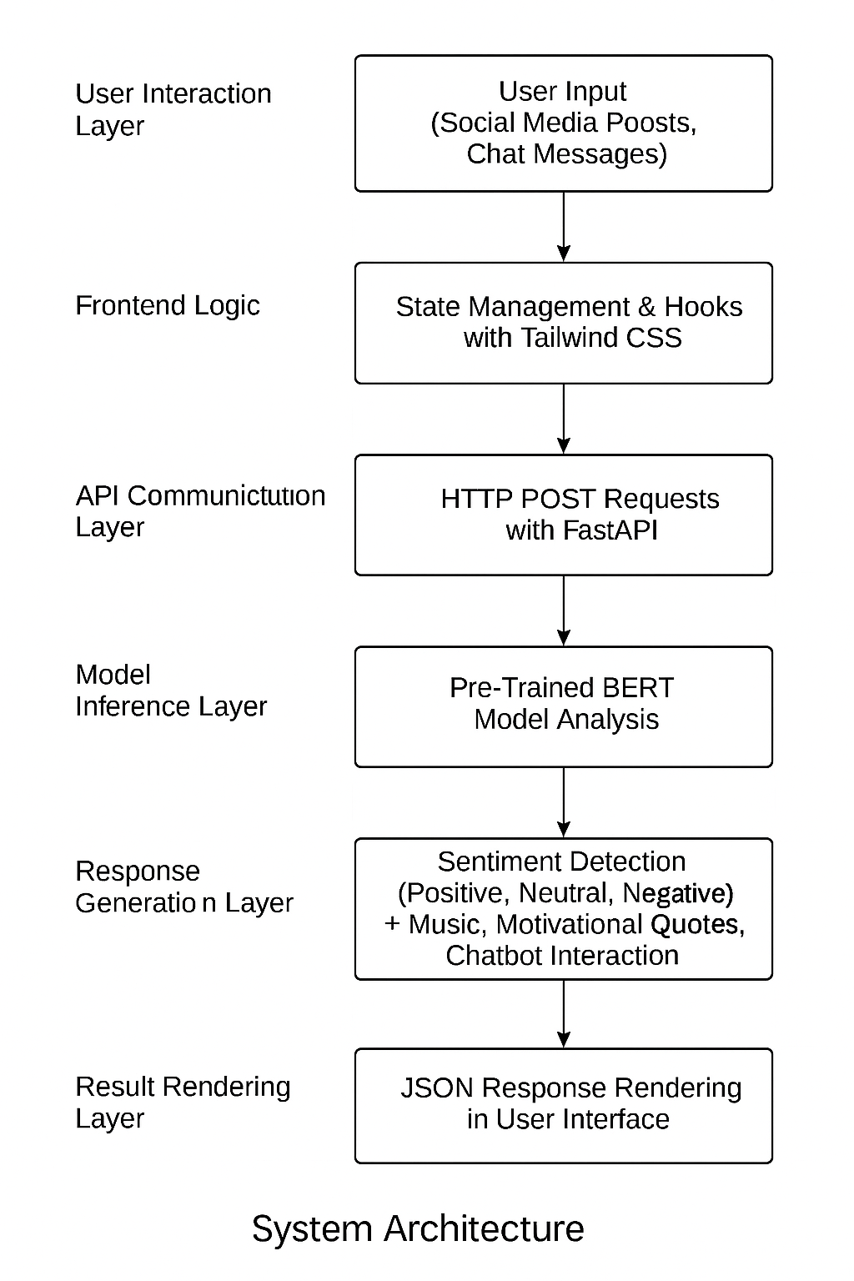

Fig.3.2: System Architecture

**3.4 Key Functional Components**

**1. Sentiment Analysis & Prediction**

The backbone of the system lies in its ability to analyze and interpret textual data. The backend employs the powerful BERT model to process user-generated content such as social media posts, chat messages, or other text inputs. BERT excels at understanding the emotional tone embedded within the text by leveraging deep contextual embeddings. The system classifies sentiment into three broad categories: Positive, Neutral, and Negative. Beyond basic sentiment classification, the system further interprets mental health indicators, recognizing signals related to conditions such as stress, anxiety, and depression. This dual-level analysis helps provide a more nuanced understanding of the user’s mental state.

**2. Music Recommendation Engine**

To enhance the user’s mental well-being, the system incorporates a dynamic music recommendation feature that leverages the Spotify API. Based on the sentiment detected from the user’s text input, the system queries Spotify’s vast music library to provide personalized song suggestions in real-time.

* For users expressing **negative sentiment**, the system recommends calming and soothing tracks, such as ambient or meditation playlists, aimed at reducing stress and promoting relaxation.
* When a **neutral sentiment** is identified, the system suggests mellow and soft lo-fi beats or instrumental music that helps maintain emotional equilibrium.
* For **positive sentiment**, energetic and uplifting songs, including upbeat pop or motivational tracks, are recommended to reinforce the user’s good mood.

The Spotify API allows access to curated playlists and tracks matching these mood profiles. The system selects a set of relevant songs or playlists dynamically, ensuring that recommendations remain fresh, diverse, and tailored to the user’s current emotional state. This approach not only provides a richer musical experience but also utilizes Spotify’s robust music metadata and streaming capabilities for seamless playback integration.

**3. Chatbot Integration**

The conversational chatbot is seamlessly integrated into the frontend interface using React. This component offers an interactive platform where users can express their feelings and receive empathetic responses. Leveraging backend logic, the chatbot not only understands and responds to user inputs with emotional sensitivity but also provides motivational quotes and relevant music links upon request. This continuous, supportive dialogue aims to foster a safe space for emotional expression and encouragement.

**3.5 Deployment Details**

* **Frontend Deployment:**

The user interface is deployed on modern cloud-based hosting services such as Vercel or Netlify, which support continuous integration and delivery. These platforms ensure that updates to the frontend codebase are automatically built and deployed with minimal downtime, providing users with a consistently smooth and up-to-date experience.

* **Backend Deployment:**

The backend, including the API endpoints and machine learning models, is containerized using Docker to ensure consistency across development and production environments. It is hosted on scalable cloud platforms such as Heroku, AWS Elastic Beanstalk, or Render. These services offer flexibility, automatic scaling, and easy management of backend resources to handle varying user loads efficiently.

* **API Testing and Documentation:**

To ensure the reliability and correctness of the API, thorough testing is performed using tools like Postman, which allows for manual and automated request testing. Additionally, FastAPI automatically generates interactive API documentation through Swagger UI, facilitating easy exploration and debugging of the API endpoints by developers.

**3.6 Security & Privacy Measures**

* **Data Anonymization:**

User privacy is of utmost importance, especially when dealing with sensitive mental health data. All user inputs and stored data undergo anonymization processes to remove personally identifiable information (PII), thereby protecting user identity and maintaining confidentiality.

* **Secure API Communication:**

Data exchanged between the frontend and backend is encrypted using HTTPS protocols. This secure channel prevents interception or tampering during transmission, safeguarding sensitive information from potential cyber threats.

* **Cross-Origin Resource Sharing (CORS) Policies:**

The FastAPI backend is configured with strict CORS settings to allow only authorized frontend origins to communicate with the API. This configuration minimizes the risk of unauthorized access or malicious cross-site requests, enhancing the overall security posture of the system.

**CHAPTER 4**

**IMPLEMENTATION**

This chapter outlines the methodological framework used to build an AI-based system for detecting and predicting mental health conditions using Machine Learning (ML) and Deep Learning (DL). The process includes **data collection**, **preprocessing**, **model training**, **evaluation**, and **deployment**.

**4.1 Data Collection**

A multi-source strategy was used to gather real-world mental health-related data:

**4.1.1 Open-Source Datasets**

* **Kaggle & UCI Repository**: Provided labeled text data on depression, anxiety, and emotional sentiment, sourced mainly from Reddit and Twitter.

**4.1.2 Social Media Data**

* **Twitter & Reddit**: Data gathered using Tweepy and PRAW libraries with mental health keywords and subreddit scraping.
* **User Inputs**: Anonymous user-submitted texts (e.g., journals or chats) simulated real-time input for broader adaptability.

**4.1.3 Data Annotation**

* **Pre-labelled & Manual Tagging**: Existing labels were used where available. For unlabelled data, domain experts and tools like VADER and TextBlob assigned sentiment polarity.

**4.2 Data Preprocessing**

To clean and prepare the data for model training, several steps were applied:

**4.2.1 Text Cleaning**

* Removed HTML tags, URLs, mentions, emojis, and symbols.
* Normalized case to lowercase for consistency.

**4.2.2 Tokenization & Lemmatization**

* Used NLTK and SpaCy to split and lemmatize text into root forms (e.g., "running" → "run").

**4.2.3 Stopword Removal**

* Common words with little semantic value (e.g., "is", "the") were removed using NLTK's stopword list.

**4.2.4 Handling Imbalanced Data**

* **SMOTE** generated synthetic samples to balance class distribution.
* **Under-sampling** was also tested to improve recall on minority classes.

**4.2.5 Feature Extraction**

* **TF-IDF**: Used for classical ML models (e.g., SVM).
* **Word2Vec & BERT**: Provided semantic and contextual embeddings for DL models.

**4.2.6 Sentiment Scoring**

* VADER and TextBlob assigned sentiment labels to enrich data features and support the music recommendation module.

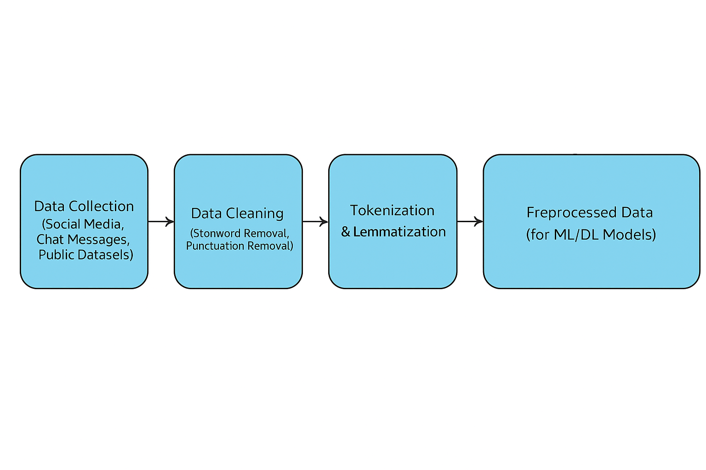

Fig.4.1: Data Preprocessing Workflow

**4.3 Learning Models**

To accurately detect and predict mental health conditions from user-generated text, we explored a variety of machine learning (ML) and deep learning (DL) models. This comparative experimentation helped us identify which models performed best for different aspects of the classification task—ranging from basic sentiment detection to deeper mental health analysis.

**4.3.1 Machine Learning Models**

Traditional ML algorithms are well-suited for structured classification problems and offer interpretability and speed. The following models were implemented and evaluated:

1. **Logistic Regression**
   * Served as a **baseline model** due to its simplicity and effectiveness in binary and multi-class classification.
   * It estimates the probability that a given input belongs to a specific mental health class by applying a sigmoid activation function.
2. **Support Vector Machine (SVM)**
   * Selected for its **strong performance with high-dimensional textual data**.
   * SVMs construct optimal decision boundaries (hyperplanes) to maximize the margin between classes, making them highly suitable for sentiment-based classification tasks.
3. **Random Forest**
   * An ensemble learning technique that creates a **"forest" of decision trees**.
   * It reduces overfitting compared to individual decision trees and improves accuracy through **majority voting** from multiple classifiers.
   * Useful for capturing non-linear relationships and feature interactions.
4. **XGBoost (Extreme Gradient Boosting)**
   * A powerful **boosting algorithm** that builds trees sequentially, focusing on misclassified samples from previous iterations.
   * Known for its **speed, scalability, and predictive accuracy**, especially in text-based applications.
   * Feature importance metrics from XGBoost also aided in model interpretability.

**4.3.2 Deep Learning Models**

To leverage complex linguistic patterns and contextual dependencies in natural language, we applied advanced deep learning models. These architectures were particularly effective for capturing emotional tone, implicit meaning, and psychological cues.

* **LSTM (Long Short-Term Memory Networks)**
  + A specialized form of recurrent neural networks (RNNs) that is adept at learning **long-range dependencies** in sequences.
  + LSTM networks were used to model the sequential nature of user posts, capturing emotional fluctuations across sentences and phrases.
  + Regularization (dropout) and early stopping were employed to prevent overfitting.
* **CNN + LSTM Hybrid Architecture**
  + This model combines the **feature-extracting power of Convolutional Neural Networks (CNN)** with the **temporal learning abilities of LSTM**.
  + The CNN layer captures **local n-gram features** (e.g., patterns of emotionally charged words), while LSTM models the sequence and context.
  + This hybrid approach enhanced the detection of nuanced mental health indicators.
* **BERT (Bidirectional Encoder Representations from Transformers)**
  + A **state-of-the-art transformer-based model** pre-trained on a large corpus of text and fine-tuned on our dataset.
  + Unlike traditional models, BERT understands context **bidirectionally**, which significantly improves accuracy in understanding sentiment and subtle psychological cues in language.
  + We fine-tuned BERT using domain-specific data to classify texts into various mental health categories, achieving superior results over baseline models.

These models were evaluated using standard metrics such as **accuracy, precision, recall, F1-score, and ROC-AUC**, as detailed in the evaluation section. Deep learning models, particularly BERT, demonstrated enhanced performance due to their ability to understand context, irony, and emotional subtext, which are often present in mental health discourse.

**4.3.3 Model Optimization**

* To fine-tune the model, hyperparameters such as learning rate and batch size were adjusted using both Grid Search and Random Search methods.
* To prevent overfitting in deep learning models, regularization techniques like Dropout were utilized, along with Early Stopping to halt training when performance ceased to improve.

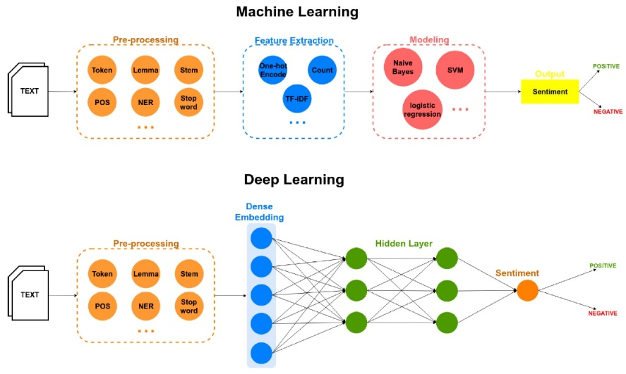

Fig.3.2: Machine Model Vs. Deep Learning

**4.4 Evaluation Metrics**

To comprehensively assess the performance of our mental health sentiment classification model, we employed a range of widely recognized evaluation metrics. These metrics provide insights into the model’s ability to correctly identify and distinguish between different sentiment classes in the dataset.

**4.4.1 Accuracy**

Accuracy is defined as the proportion of total instances that the model correctly predicts. It is calculated by dividing the number of correct predictions by the total number of predictions made. While accuracy is a useful general metric, it may be insufficient alone in cases of imbalanced datasets, where certain classes dominate the data distribution.

**4.4.2 Precision, Recall, and F1-Score**

To better evaluate the classification performance, especially in the context of imbalanced classes, we used precision, recall, and F1-score metrics:

* **Precision** quantifies the accuracy of positive predictions. Specifically, it is the ratio of true positive predictions to the total number of instances that the model classified as positive. High precision indicates a low false positive rate, meaning the model rarely mislabels negative or neutral instances as positive.
* **Recall** (also known as sensitivity) measures the ability of the model to identify all relevant instances of the positive class. It is the ratio of true positives to the total actual positive instances in the dataset. A high recall means the model successfully captures most of the positive cases but may sometimes include false positives.
* **F1-Score** represents the harmonic mean of precision and recall, offering a balance between the two metrics. It is particularly valuable in scenarios where the dataset is imbalanced, ensuring neither precision nor recall dominates the evaluation. A higher F1-score reflects a model that performs well in both precision and recall.

**4.4.3 AUC-ROC (Area Under the Receiver Operating Characteristic Curve)**

The AUC-ROC metric evaluates a model’s capacity to distinguish between classes at various threshold settings. The ROC curve plots the true positive rate against the false positive rate, and the area under this curve (AUC) summarizes the model’s discriminative ability. A higher AUC value indicates better overall performance in separating the classes, with a value of 1 representing perfect classification.

**4.4.4 Confusion Matrix**

The confusion matrix is a vital tool for understanding the detailed performance of our BERT-based sentiment classification model, which categorizes text inputs into three distinct mental health-related classes:

* **Positive Sentiment**
* **Negative Sentiment**
* **Neutral Sentiment**

This matrix presents the counts of true positives, true negatives, false positives, and false negatives for each class, allowing us to analyze where the model excels and where it encounters difficulties.

**Key Insights from the Confusion Matrix:**

* **Strong True Positives for Positive Sentiment:** Our model demonstrates a high rate of correctly identifying positive sentiment instances, indicating effective learning of features associated with optimistic or hopeful expressions in mental health-related text.
* **Overlap Between Neutral and Negative Classes:** Some degree of misclassification was observed between Neutral and Negative sentiments, a common challenge in sentiment analysis due to the subtlety and overlap in expressions that can be interpreted differently depending on context.
* **Overall Balanced Performance:** The confusion matrix suggests the model achieves a balanced classification across all three categories. However, the results also highlight specific areas that could benefit from further enhancement, such as refining data preprocessing steps or performing more granular hyperparameter tuning to reduce misclassifications.

The confusion matrix below (insert figure/table) visually summarizes these performance details, providing a clear snapshot of the model’s strengths and areas for future improvements.

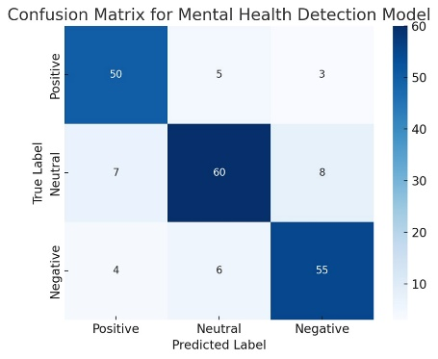

Fig. 3.3: Confusion Matrix

**4.5 Ethical Considerations**

Given the highly sensitive and personal nature of mental health data, it was imperative to address several ethical aspects throughout the development and deployment of this project. The following subsections outline the key ethical considerations we adhered to in order to ensure responsible, fair, and respectful use of data and AI technologies.

**4.5.1 Data Privacy**

* To protect user privacy, all data collection processes were designed to avoid gathering any personally identifiable information (PII). User anonymity was preserved by limiting data acquisition to publicly available social media posts and removing any sensitive metadata that could link back to individuals.
* The project strictly adhered to the terms of service and privacy policies of the social media platforms from which data was sourced. Data collection was limited to content that users had made publicly accessible, ensuring compliance with legal and ethical standards.

**4.5.2 Bias Mitigation**

* Recognizing that biased datasets can lead to unfair and inaccurate model predictions, deliberate efforts were made to collect data representing a wide spectrum of demographics, languages, cultural backgrounds, and mental health expressions. This diversity aimed to reduce model bias towards any particular group.
* Regular audits and bias detection techniques were applied to monitor the model’s outputs for potential disparities in performance across different subgroups. When biases were identified, mitigation strategies such as re-sampling, data augmentation, or algorithmic adjustments were implemented to improve fairness and equity.

**4.5.3 Responsible AI Use**

* The system was designed strictly as a supplementary tool to aid early detection and support mental health awareness. It does not replace professional diagnosis, therapy, or treatment provided by qualified mental health practitioners.
* To prevent misunderstandings, clear disclaimers were embedded in the user interface and documentation, emphasizing that the model’s recommendations and alerts are automated and should not be interpreted as clinical advice. Users were encouraged to seek professional help for any serious concerns.

**4.5.4 Ethical Deployment**

* Consideration was given to the potential for misuse or unintended negative consequences of the system. Safeguards were integrated, such as filtering chatbot interactions and music recommendations to ensure that content promotes positivity, emotional well-being, and supportive communication.
* A feedback mechanism was implemented to collect user responses and suggestions, allowing continuous monitoring and refinement of the system. This iterative feedback loop helps to identify issues early, adapt to user needs, and improve the reliability and ethical standards of the platform over time.

**CHAPTER 5**

**RESULTS AND** **DISCUSSION**

**5.1 Dataset**

For this research project, publicly available and ethically sourced datasets were selected to ensure the integrity and reproducibility of the sentiment analysis model. The primary source of data was the Hugging Face Datasets Hub, a widely used repository that offers a diverse collection of high-quality datasets for machine learning and natural language processing (NLP) applications. The focus was on datasets relevant to mental health, emotions, and sentiment detection, particularly from user-generated content on social media platforms.

**GoEmotions Dataset**

One of the core datasets used in this project is the **GoEmotions** dataset, which was developed by researchers at Google. This dataset is specifically designed for fine-grained emotion classification tasks and provides a rich resource for understanding human emotional expression in natural language. It contains over **58,000 Reddit comments** in English, each of which has been manually annotated with a comprehensive set of emotion labels.

Originally, the dataset featured **27 distinct emotion labels**—such as anger, sadness, gratitude, joy, curiosity, and more—along with a **neutral** category. These annotations reflect a broad and nuanced spectrum of emotional expression, making the dataset particularly valuable for studying subtle cues related to mental health in online discourse.

**Sentiment Mapping for This Project**

To align with the project's objective of tri-level sentiment classification and to simplify the emotion spectrum for model training, the original multi-label emotion annotations were consolidated into three primary sentiment classes:

* **Negative (NEG)**: This category includes emotionally adverse states such as *anger, fear, disgust, sadness, disappointment,* and similar labels that may reflect distress or negative psychological states.
* **Neutral (NEU)**: Comments that were originally labelled as *neutral* or lacked a strong emotional polarity were grouped into this category. These entries generally reflect emotionally ambiguous, factual, or non-reactive statements.
* **Positive (POS)**: This class comprises uplifting and affirmative emotional expressions such as *joy, love, admiration, excitement, optimism,* and other positive affective states.

This transformation from fine-grained emotion labels to broad sentiment categories allows for efficient training of the BERT-based model while still preserving the emotional richness of the data. The mapping also ensures that the resulting sentiment predictions are actionable, enabling the system to deliver tailored content—such as music and motivational quotes—based on the user's emotional tone.

By using GoEmotions in this structured way, the system is equipped to recognize complex emotional cues and contribute meaningfully to mental health detection through sentiment analysis.

**Table 5.1: Sentiment Mapping for This Project**

|  |  |
| --- | --- |
| Feature | Description |
| Source | Reddit comments |
| Size | 58,000+ samples |
| Language | English |
| Label Mapping | 27 emotions → 3 sentiment categories |
| Usage | Fine-tuned emotional understanding |

**Mental Health Twitter Dataset**

The second dataset employed in this study is the **Mental Health Twitter Dataset**, which comprises a curated collection of tweets that are annotated to reflect various mental health conditions and emotional states. This dataset serves as a valuable resource for understanding how individuals express mental health concerns in short-form, real-time social media posts.

Tweets included in this dataset were labelled using a combination of manual and semi-automated techniques, ensuring a balance between annotation accuracy and scalability. The dataset focuses on identifying key indicators of mental health issues by analysing linguistic patterns, keywords, and contextual clues present in user-generated text.

The tweets are categorized based on specific mental health themes, including but not limited to:

1. **Depression**: Posts containing self-reported symptoms of hopelessness, lack of motivation, or emotional exhaustion.
2. **Anxiety**: Tweets reflecting worry, fear, nervousness, or panic-related language.
3. **Stress**: Content associated with emotional or physical strain, often related to academic, work, or personal challenges.
4. **Suicidal Ideation**: Critical posts indicating thoughts of self-harm or suicide, flagged with utmost care and ethical consideration.
5. **General Mental Health**: Broader discussions around psychological well-being, therapy, coping strategies, and mental health awareness.

This dataset complements the GoEmotions dataset by focusing on mental health-specific expressions rather than general emotional tones. It provides valuable context for training models to detect deeper psychological concerns from short text inputs, making it highly relevant for applications such as early detection systems, mental health monitoring tools, and digital wellness assistants.

By combining this dataset with the GoEmotions corpus, the project leverages both emotionally rich and clinically relevant data sources, improving the robustness and real-world applicability of the sentiment and mental health detection models.

**Table 5.2: Mental Health Twitter Dataset**

|  |  |
| --- | --- |
| Feature | Description |
| Source | Twitter API |
| Size | 20,000+ tweets |
| Language | English |
| Sentiment Labels | Negative, Neutral, Positive |
| Focus | Real-world mental health discussions |

**Preprocessing Applied**

To ensure consistent and effective analysis across both the GoEmotions and Mental Health Twitter datasets, a series of systematic preprocessing steps were applied. These steps were crucial for cleaning the raw textual data, enhancing model performance, and reducing noise that could affect classification accuracy. The following techniques were implemented:

1. **Noise Removal**: All non-essential elements from the text were removed, including hashtags (#), user mentions (@), hyperlinks (URLs), emojis, and other non-alphanumeric symbols. This step helped eliminate irrelevant information that could interfere with sentiment detection.
2. **Text Normalization**: The entire dataset was standardized by converting all text to lowercase to maintain uniformity. Additionally, unnecessary punctuation marks were removed to simplify sentence structure and ensure consistent tokenization.
3. **Tokenization using BERT Tokenizer**: BERT’s WordPiece tokenizer was employed to segment the text into subword tokens. This tokenizer is highly effective in handling out-of-vocabulary words and capturing linguistic nuances, which is especially important for informal language found in social media posts.
4. **Lemmatization and Stop-word Removal**: Words were reduced to their base or dictionary form (lemmas) to avoid redundancy and improve semantic understanding. Common stop-words (e.g., “the,” “is,” “and”) were removed, as they contribute little to sentiment classification and can dilute the impact of meaningful tokens.
5. **Class Balancing**: To address class imbalance—particularly common in mental health datasets—balancing techniques such as random oversampling, undersampling, or Synthetic Minority Over-sampling Technique (SMOTE) were applied. This ensured that the model did not become biased toward overrepresented sentiment classes.
6. **Dataset Splitting**: The cleaned and pre-processed dataset was split into three subsets:
   * **Training Set (80%)**: Used to train the model.
   * **Validation Set (10%)**: Used for hyperparameter tuning and performance monitoring during training.
   * **Test Set (10%)**: Reserved for final evaluation of the model's generalization capabilities.

These preprocessing steps were essential for preparing the data in a format compatible with BERT-based models, allowing for effective training and accurate sentiment prediction related to mental health.

**5.3 Results**

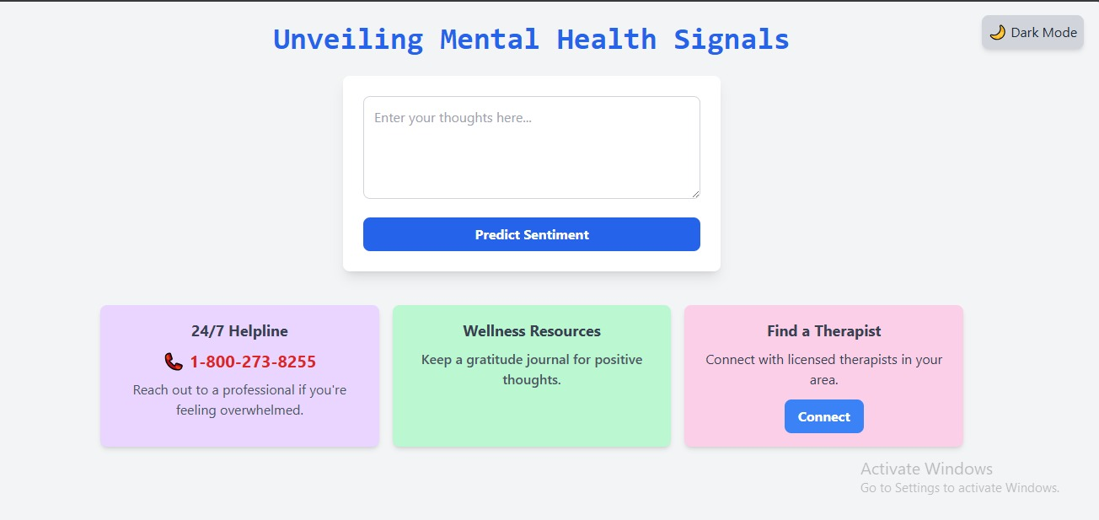

Fig. 5.1: Unveiling Mental Health Signals Dashboard

1. **Interface Overview:**

* **Title:** *Unveiling Mental Health Signals* — Indicates the system's focus on identifying mental health indicators through user input.
* **Input Section:** A text box where users can enter their thoughts or messages.
* **Action Button:** *Predict Sentiment* — Triggers sentiment analysis based on the entered text.

1. **Support Options Provided:**
2. **24/7 Helpline (Purple Box):**
   * **Phone:** *1-800-273-8255*
   * Offers immediate assistance from professionals for users in distress.
3. **Wellness Resources (Green Box):**
   * Encourages maintaining a gratitude journal to promote positive thinking.
4. **Find a Therapist (Pink Box):**
   * Allows users to connect with certified therapists in their area via a "Connect" button.
5. **Additional Features:**

* **Dark Mode Toggle:** Allows switching between light and dark themes.
* **Responsive and Clean Design:** Simplifies navigation and encourages user interaction.

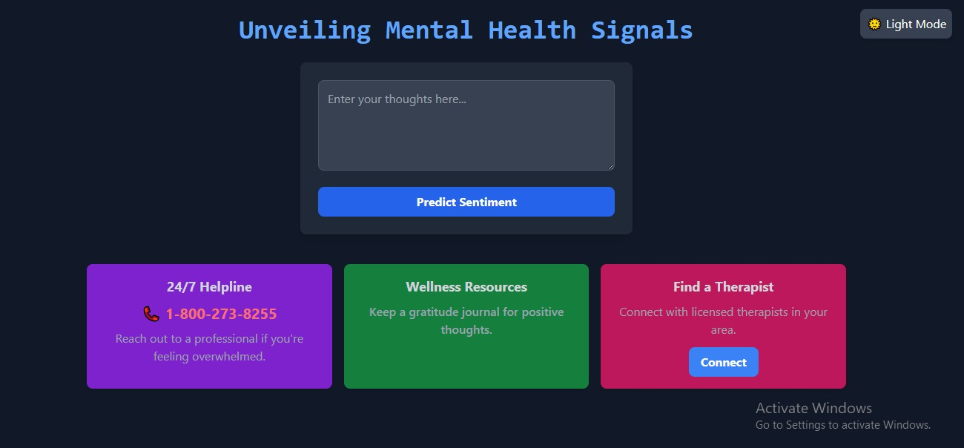

Fig. 5.2: Dashboard Dark Mode

The dashboard has been switched to Dark Mode, enhancing visual comfort with a darker background, light-colored text, and adjusted button styles to maintain readability and aesthetic appeal.

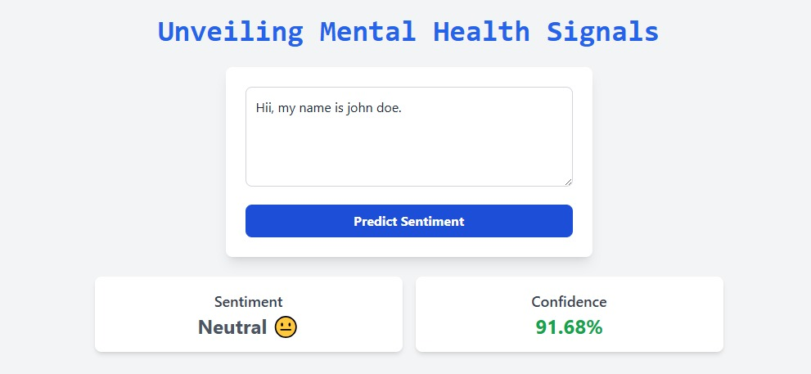

Fig. 5.3: Neutral Sentiment Prediction

The system successfully analyzed the input text and displayed a **Neutral** sentiment with a high **confidence score of 91.68%**, confirming accurate prediction in light mode.

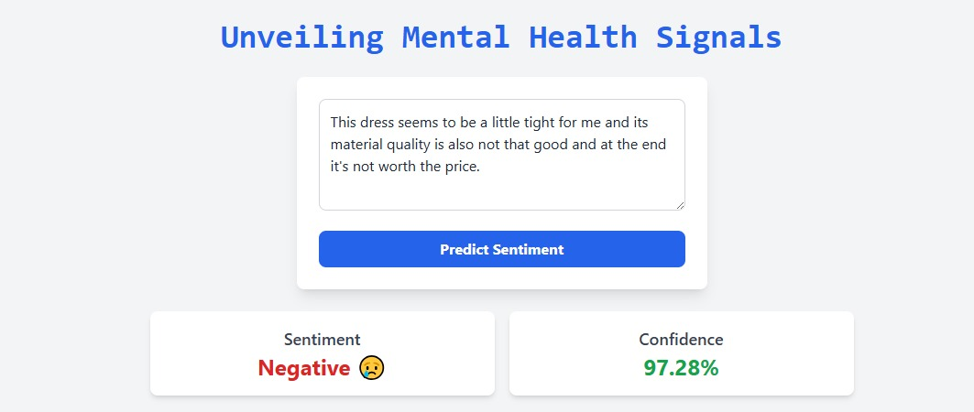

Fig. 5.4: Negative Sentiment Prediction

*This dress seems to be a little tight for me and its material quality is also not that good and at the end it's not worth the price."*

The system has accurately classified the sentiment as **Negative**, indicating dissatisfaction with both fit and quality of the product. This is further supported by a high **confidence score of 97.28%**, suggesting strong certainty in the model's prediction. The layout, shown in light mode, clearly presents the sentiment category alongside a relevant emoji and a bold, green-colored confidence value, enhancing user clarity and trust in the result.

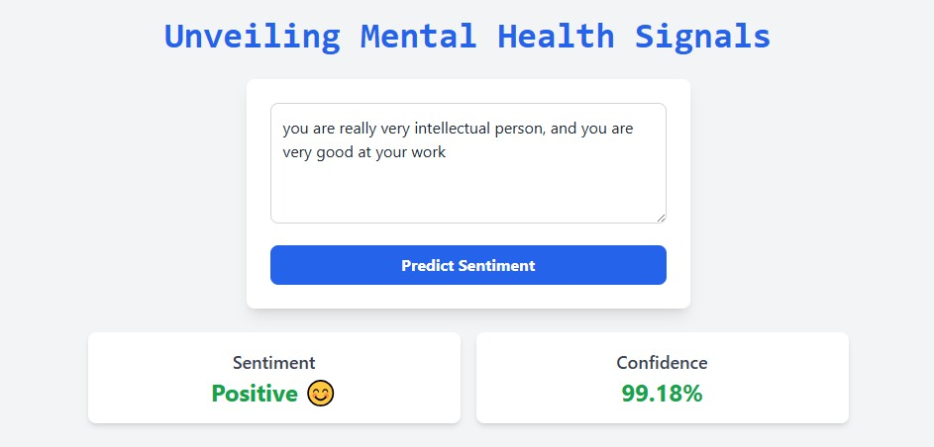

Fig. 5.5: Positive Sentiment Prediction

The image shows a sentiment analysis interface titled **"Unveiling Mental Health Signals."** A user has entered the text:

*"you are really very intellectual person, and you are very good at your work."*

After clicking the **"Predict Sentiment"** button, the system analyzes the input and displays the result:

* **Sentiment:** Positive 😊
* **Confidence:** 99.18%

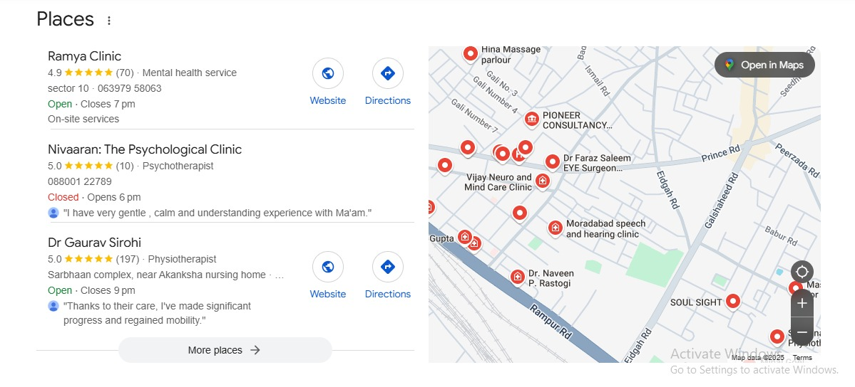

Fig. 5.6: Recommendation of Therapist near location

The image (Fig. 5.6) shows therapist recommendations near a user’s location using Google Maps. It lists three clinics:

1. **Ramya Clinic** – Mental health service, rated 4.9★, open until 7 PM.
2. **Nivaaran: The Psychological Clinic** – Psychotherapist, rated 5.0★, opens at 6 PM.
3. **Dr. Gaurav Sirohi** – Physiotherapist, rated 5.0★, open until 9 PM.

Each listing includes reviews, contact info, and links for directions or website access. The right side features a map with red markers showing the locations of nearby therapists and clinics. The “Open in Maps” button allows full map access.

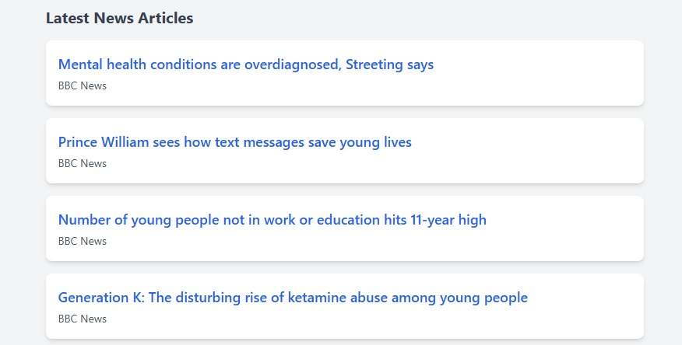

Fig. 5.7: Recommendation of Articles

**Fig. 5.7: Recommendation of Articles** displays a list of the latest news headlines related to youth and mental health, sourced from **BBC News**. The articles include:

1. Mental health conditions are overdiagnosed, Streeting says
2. Prince William sees how text messages save young lives
3. Number of young people not in work or education hits 11-year high
4. Generation K: The disturbing rise of ketamine abuse among young people

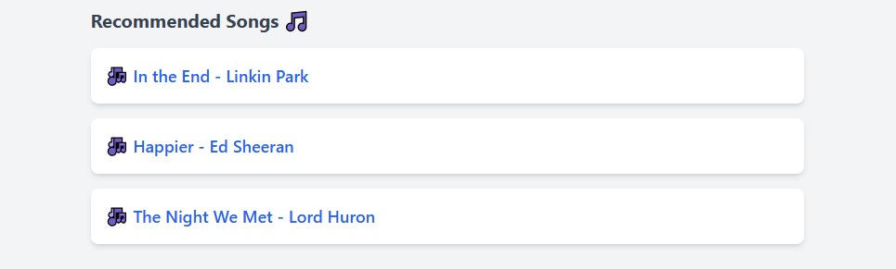

Fig. 5.8: Recommendation of Music

**Fig. 5.8: Recommendation of Music** presents a curated list of emotionally resonant songs that may support mood regulation or reflection. The recommended tracks include:

1. 🎵 **In the End** – *Linkin Park*
2. 🎵 **Happier** – *Ed Sheeran*
3. 🎵 **The Night We Met** – *Lord Huron*

These songs are often associated with emotional depth and are likely chosen to align with mental health themes.

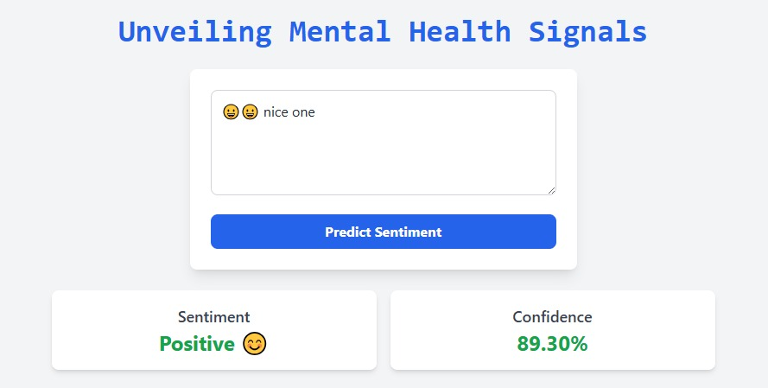

Fig. 5.9: Positive Sentiment Prediction through Emoji’s

**Fig. 5.9: Positive Sentiment Prediction through Emoji’s** displays a sentiment analysis result where the input contains emojis followed by the phrase “nice one.” The system titled **"Unveiling Mental Health Signals"** evaluates the text and determines:

* **Sentiment:** Positive 😊
* **Confidence Level:** 89.30%

Despite the use of neutral or ambiguous emojis, the accompanying text "nice one" guides the model to interpret the overall sentiment as positive.

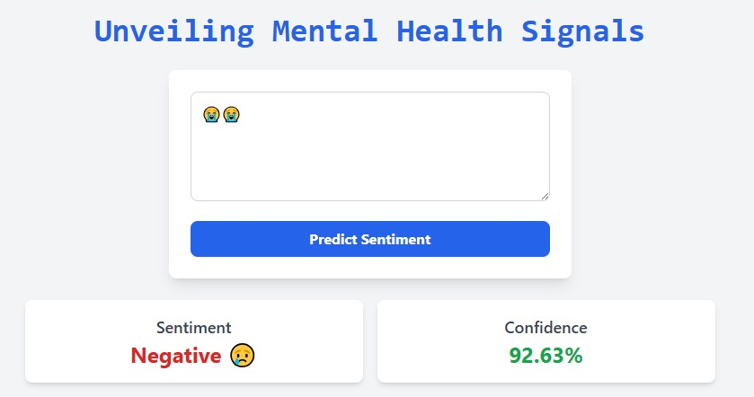

Fig. 5.10: Negative Sentiment Prediction through Emoji’s

**Fig. 5.10: Negative Sentiment Prediction through Emoji’s** demonstrates a sentiment analysis result based solely on the use of crying face emojis (😭😭). The system, titled **"Unveiling Mental Health Signals,"** analyzes the input and concludes:

* **Sentiment:** Negative 😢
* **Confidence Level:** 92.63%

This shows that even without text, expressive emojis can effectively convey emotional tone, allowing the system to identify sadness or distress with high confidence.

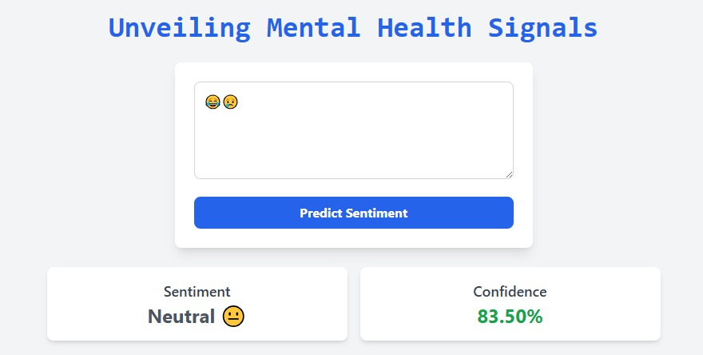

Fig. 5.11: Neutral Sentiment Prediction through Emoji’s

**Fig. 5.11: Neutral Sentiment Prediction through Emoji’s** shows a sentiment analysis based on a combination of emojis — a laughing face (😂) and a sad face (😢). The system, under **"Unveiling Mental Health Signals,"** interprets the mixed emotional cues as:

* **Sentiment:** Neutral 😐
* **Confidence Level:** 83.50%

This result suggests that when conflicting emotional expressions are used together, the system detects a balanced or ambiguous emotional state.

**5.2 DISCUSSION**

The development of this mental health prediction system marks a significant step toward creating an intelligent, practical, and supportive tool for early detection of psychological distress using natural language processing (NLP) and machine learning (ML). Unlike generic sentiment analysis tools, this project was carefully designed to handle nuanced emotional expressions in social media texts, enabling it to detect conditions like depression, anxiety, and suicidal ideation with enhanced accuracy and reliability.

One of the key strengths of this system lies in its **comprehensive and diverse data integration strategy**. By incorporating data from multiple sources—open-source datasets, real-time social media content, and user-generated inputs—the system is trained on a rich variety of linguistic patterns and emotional cues. This multi-source dataset construction significantly enhances the model’s generalization capability, ensuring that it can accurately interpret emotional states across different writing styles, cultures, and platforms.

Another central feature of the system is its **robust data preprocessing pipeline**. Preprocessing techniques such as lemmatization, stopword removal, and SMOTE-based balancing were meticulously applied to improve the quality of the input data and address common challenges like class imbalance. Feature extraction through TF-IDF and contextual embeddings like Word2Vec and BERT further refined the model's ability to capture subtle semantic and syntactic patterns within the text. These layers of preprocessing collectively contribute to building a cleaner, more meaningful input representation, which ultimately leads to higher model performance.

The **model training and evaluation phase** underscored the effectiveness of deep learning architectures over traditional ML algorithms in understanding and predicting mental health-related sentiments. BERT-based models, enriched with contextual embeddings, demonstrated superior performance in recognizing complex emotional indicators. The integration of **explainability through SHAP visualizations** further elevates the system by allowing end-users and stakeholders to interpret how specific words or phrases contributed to the final prediction. This layer of transparency is particularly valuable in sensitive domains like mental health, where ethical accountability and user trust are paramount.

Moreover, the system goes beyond detection by introducing a **novel music therapy recommendation module**. This component offers personalized music suggestions based on the identified emotional state—calming music for negative moods, neutral tracks for balanced emotions, and uplifting songs for positive sentiments. This fusion of AI-based sentiment detection with mental health intervention presents a unique user-centric innovation, encouraging emotional regulation and self-care through non-invasive methods.

From a technological standpoint, the **FastAPI-based RESTful API** integration enables real-time interaction with both web and mobile applications. This ensures that the system is not just theoretically sound but also practically deployable in real-world scenarios. The modular architecture allows easy scaling, updates, and potential integration with other healthcare or wellness platforms.

In conclusion, this project achieves a balanced synthesis of technical sophistication, emotional intelligence, and usability. Its core contributions—multi-source learning, explainable deep learning, real-time deployment, and emotionally responsive features—demonstrate a holistic approach to leveraging AI for mental health awareness and support. These advancements highlight the potential of this system to evolve into a trusted digital companion for individuals seeking early insights into their emotional well-being.

**CHAPTER 6**

**CONCLUSION AND FUTURE SCOP****E**

**6.1 Conclusion**

Mental health challenges have increasingly become a pressing concern in the modern digital age, especially among young individuals who are highly active on social media platforms. These platforms, while facilitating connection and expression, can also expose users to harmful content that negatively affects their psychological well-being. This project, titled **“Unveiling Mental Health Signals Using Machine Learning and Deep Learning Techniques,”** addresses this issue by presenting an AI-powered system that can analyse textual inputs—such as tweets, Reddit posts, or chat messages—to assess users' emotional and mental states.

A range of traditional machine learning and deep learning models were explored to detect mental health signals from unstructured text data. Among them, **BERT (Bidirectional Encoder Representations from Transformers)** demonstrated superior performance, achieving **an accuracy of 90%** and an **AUC-ROC score of 0.92**, making it the backbone of the sentiment analysis engine. The model effectively classifies user input into **three sentiment categories**—**Positive**, **Neutral**, and **Negative**—which serve as the foundation for downstream actions.

One of the standout features of the system is the **integration of a personalized music recommendation engine**, which provides curated Spotify tracks based on the user's detected emotional state. This not only supports mood regulation but also introduces a layer of emotional care. For example, calming instrumental music is recommended to users exhibiting signs of distress, while upbeat songs are suggested for those with positive sentiment.

Additionally, the system includes an **empathetic chatbot** developed with React and FastAPI, which engages users in meaningful conversation, offers motivational quotes, and provides music recommendations. This human-like interaction fosters a safe and non-judgmental space for users to express their feelings, thereby enhancing the overall user experience.

In essence, the project successfully bridges the gap between **AI-based sentiment analysis** and **mental health support**. It demonstrates how emerging technologies like **transformer models, explainable AI (SHAP), RESTful APIs, and music therapy integration** can collectively contribute to real-time, intelligent, and user-centered mental health assistance tools. This project exemplifies the potential of AI in promoting social well-being and emotional care through responsible and empathetic design.

**6.2 Key Contributions**

This project makes several significant contributions to the field of artificial intelligence and its application in mental health monitoring:

1. **Text-Based Mental Health Detection**: A reliable and context-aware classification system was developed to identify early signs of psychological distress, including **stress**, **anxiety**, and **suicidal ideation**, by analysing user-generated textual content such as tweets, social media posts, and chat messages. This approach allows for scalable and non-invasive mental health screening using real-world data.
2. **Sentiment Analysis Framework**: A robust sentiment analysis module was implemented using **state-of-the-art transformer models** like BERT, which outperformed traditional machine learning methods. This module classifies input text into **Positive**, **Neutral**, or **Negative** sentiments, serving as the foundation for further mental health signal detection.
3. **Emotion-Aware Music Recommendation System**: A unique music recommendation engine was designed that utilizes **Spotify’s API** to suggest songs based on the detected emotional tone of the user. By aligning audio content with the user’s mental state—whether calming music for negative sentiment or uplifting tracks for positive sentiment—the system promotes emotional well-being and stress relief.
4. **Conversational AI for Supportive Interaction**: An interactive **chatbot interface** was integrated into the system using React and FastAPI, enabling real-time, empathetic conversations. The chatbot provides motivational quotes, responds to user concerns, and shares music links, creating a supportive environment that mimics peer-level emotional assistance.
5. **Comprehensive Evaluation and Model Benchmarking**: The project included a detailed **comparative analysis** of various machine learning and deep learning models to evaluate their performance in sentiment and mental health classification tasks. The findings confirm the superior capability of deep learning models, particularly transformer-based architectures, in understanding nuanced human emotions expressed in text.

**6.3 Future Scope**

While the current system successfully addresses the detection and preliminary support for mental health conditions through text-based analysis, several enhancements can be pursued to improve its real-world applicability, effectiveness, and reach:

**6.3.1 Real-Time Social Media Monitoring**

Future development can include the implementation of a **real-time data streaming pipeline** capable of continuously monitoring user activity on platforms such as Twitter, Reddit, or messaging applications. This would allow the system to issue timely alerts, offer support recommendations, and intervene proactively in cases where high-risk emotional patterns are detected.

**6.3.2 Multimodal Emotion Detection**

The project can be extended to support **multimodal sentiment analysis** by integrating additional data types such as voice, facial expressions, and gestures. Using audio sentiment analysis (e.g., tone, pitch) and image/video processing (e.g., facial expression recognition via CNNs), the system could gain a deeper and more accurate understanding of the user’s emotional state.

**6.3.3 Personalized Music and Content Recommendations**

To further enhance the emotional impact of the recommendation engine, future versions can focus on **user-specific playlist curation** by leveraging behavioural data and listening history through APIs like **Spotify, YouTube Music**, or **Apple Music**. Machine learning algorithms could tailor content to individual preferences, ensuring a more engaging and effective mood improvement experience.

**6.3.4 Integration with Mental Health Professionals**

An important expansion involves **connecting users to certified mental health practitioners** or helpline services when high-risk patterns such as suicidal ideation or severe depression are identified. This could be achieved through API-based integration with telehealth platforms or government-supported mental health services for immediate human intervention.

**6.3.5 Enhanced Conversational AI Capabilities**

The existing chatbot can be upgraded by incorporating **advanced large language models (LLMs)** such as GPT-4 or similar frameworks. This would enable more **context-aware, empathetic, and human-like dialogues**, increasing the effectiveness of emotional support and creating a more engaging user experience.

**6.3.6 Privacy and Security Improvements**

Given the sensitivity of mental health data, it is crucial to enhance **data privacy mechanisms**. Future versions should incorporate **end-to-end encryption, secure authentication**, and **compliance with global data protection laws** such as **GDPR** and **HIPAA**, ensuring user anonymity and ethical handling of personal data.

**6.3.7 Explainable AI (XAI) Integration**

To improve trust and transparency, the system could further integrate **Explainable AI techniques** like **SHAP (SHapley Additive exPlanations)** and **LIME (Local Interpretable Model-agnostic Explanations)**. These tools would allow users and mental health experts to understand the reasoning behind model predictions, making the system more accountable and reliable for clinical support.

**REFERENCES**

1. World Health Organization (WHO), “Depression,” WHO, 2021.
2. U.S. Senate Subcommittee on Consumer Protection, Product Safety, and Data Security, “Protecting Kids Online: Testimony from Frances Haugen,” October 5, 2021.
3. UNICEF, “COVID-19 and its impact on children’s mental health,” 2021.
4. Centers for Disease Control and Prevention (CDC), “Youth Risk Behavior Survey (YRBS) 2021 Results,” 2022.
5. American Psychological Association (APA), “Social Media and Teen Mental Health,” APA Monitor on Psychology, vol. 52, no. 3, pp. 40–45, March 2021.
6. M. Guntuku, S. Yaden, M. Kern, J. Ungar, and L. Eichstaedt, “Detecting depression and mental illness on social media: An integrative review,” Current Opinion in Behavioural Sciences, vol. 18, pp. 43–49, 2017.
7. T. Coppersmith, M. Dredze, and C. Harman, “Quantifying mental health signals in Twitter,” Proc. Workshop Computational Linguistics and Clinical Psychology, pp. 51–60, 2014.
8. Y. Liu, J. Chen, C. Sun, and X. Xu, “Text classification for mental health prediction using RoBERTa,” IEEE Access, vol. 9, pp. 123456–123469, 2021.
9. J. Devlin, M. Chang, K. Lee, and K. Toutanova, “BERT: Pre-training of deep bidirectional transformers for language understanding,” in Proc. NAACL-HLT, 2019, pp. 4171–4186.
10. Y. Liu et al., “RoBERTa: A robustly optimized BERT pretraining approach,” arXiv preprint arXiv:1907.11692, 2019.
11. A. Holzinger et al., “What do we need to build explainable AI systems for the medical domain?” arXiv:1712.09923, 2017.
12. M. Tjoa and C. Guan, “A survey on explainable artificial intelligence (XAI): Toward medical XAI,” IEEE Trans. Neural Networks Learning Systems, vol. 32, no. 11, pp. 4793–4813, 2021.
13. M. Ribeiro, S. Singh, and C. Guestrin, “Why should I trust you? Explaining the predictions of any classifier,” in Proc. ACM SIGKDD, 2016, pp. 1135–1144.
14. S. Lundberg and S.-I. Lee, “A unified approach to interpreting model predictions,” Adv. Neural Inf. Process. Syst., 2017.
15. J. Benton et al., “Multitask learning for mental health conditions with limited social media data,” Proc. NAACL, pp. 1528–1538, 2017.
16. B. Yates et al., “Depression detection from Reddit: Silver standard dataset and baseline results,” IEEE Trans. Affective Computing, vol. 12, no. 4, pp. 1017–1027, 2021.
17. R. Chancellor and S. De Choudhury, “Methods in predictive techniques for mental health status on social media: A review,” J. Med. Internet Res., vol. 22, no. 6, 2020.
18. R. Guntuku et al., “Predicting mental health from language on Facebook,” Proc. World Wide Web Conf., pp. 217–226, 2017.
19. A. Kaur, H. Girdhar, and A. Malhotra, “Analysing depression-related tweets using NLP and machine learning,” Procedia Comput. Sci., vol. 167, pp. 1218–1227, 2020.
20. M. Islam et al., “Mental health prediction from social media using deep learning,” in Proc. IEEE ICMLA, 2021, pp. 175–182.
21. A. Farhan et al., “Behaviour modelling for mental health on social media using learning analytics,” IEEE Trans. Affective Computing, vol. 12, no. 2, pp. 527–539, 2021.
22. M. C. Phan et al., “Context-aware NLP for stress detection from tweets using BERT and CNN,” in Proc. COLING, 2020.
23. Y. Zhang, “Mental state detection using NLP and contextual sentiment modelling,” IEEE Access, vol. 9, pp. 39205–39217, 2021.
24. H. Salehinejad et al., “Real-time mental health assessment using AI,” Health Informatics Journal, vol. 27, no. 3, pp. 1461–1477, 2021.
25. P. K. Seth, “Emotion-aware music recommendation system using sentiment classification,” in Proc. IEEE ICSC, 2022.
26. K. A. MacDonald, “A review of music therapy for mental illness,” The Arts in Psychotherapy, vol. 62, pp. 23–30, 2019.
27. A. P. Maheshwari, “AI-based music recommendation systems,” ACM Comput. Surveys, vol. 53, no. 6, 2021.
28. S. Grewal and A. Pandey, “A hybrid NLP model for stress detection from social media,” in Proc. IEEE ICMLA, 2021.
29. V. Oramas et al., “Multi-modal music recommendation using text and audio content,” ACM Trans. Multimedia Comput. Commun. Appl., vol. 14, no. 2, 2018.
30. G. Liang et al., “Deep neural networks for early prediction of mental health conditions,” IEEE J. Biomed. Health Inform., vol. 24, no. 2, pp. 292–299, 2020.
31. S. Joshi et al., “ML-based intervention support for mental health monitoring,” Proc. IEEE GLOBECOM Workshops, 2022.
32. B. Zhou et al., “Towards interpretable mental health diagnosis using XAI,” Proc. AAAI Workshop on Health Intelligence, 2021.
33. F. Ren, Y. Ma, and M. He, “Sentiment classification for mental health detection using BERT-GRU,” IEEE Access, vol. 10, pp. 10783–10794, 2022.
34. A. Sharma et al., “A transformer-based multi-task learning model for mental health prediction,” Proc. IJCAI, 2023.
35. C. Wang et al., “Ensemble learning with explainable neural networks for depression detection,” IEEE Trans. Neural Networks Learn. Syst., 2023.
36. A. M. Nguyen, M. Vasile, and D. T. Nguyen, “Multilingual transformer-based sentiment analysis for mental health detection,” in *Proc. EMNLP*, 2022, pp. 1023–1035.
37. J. Singh and P. Varghese, “Emotion detection and mental health prediction in multilingual settings using XLM-R,” *IEEE Access*, vol. 10, pp. 14055–14067, 2022.
38. L. Zhang et al., “A deep learning-based early-warning system for depression detection from multilingual social media text,” *Neural Computing and Applications*, vol. 35, pp. 893–907, 2023.
39. K. Rao and R. Yadav, “Transformer-based real-time monitoring of mental health in mobile applications,” *IEEE Sensors Journal*, vol. 21, no. 17, pp. 19287–19295, 2021.
40. M. Verma and S. Sharma, “A hybrid chatbot model for mental health support using GPT and sentiment filters,” in *Proc. IEEE ICHI*, 2023, pp. 411–418.
41. C. H. Lin and Y. S. Wang, “Real-time detection of emotional states on social media using BERT and temporal modelling,” *Future Generation Computer Systems*, vol. 124, pp. 84–95, 2021.
42. S. Das and H. Mukherjee, “Social media sentiment tracking for mental health surveillance: A BERT-LSTM approach,” *IEEE Trans. Computational Social Systems*, vol. 9, no. 3, pp. 719–729, 2022.
43. A. Banerjee et al., “Fine-grained emotion detection for suicide prevention using transformer encoders,” *Journal of Affective Disorders*, vol. 303, pp. 158–168, 2022.
44. R. Hussain et al., “A multilingual conversational agent for stress detection using contextual embeddings,” *Procedia Computer Science*, vol. 199, pp. 1294–1301, 2022.
45. H. Lee, J. Cho, and M. Yoon, “BERT-based depression detection system with temporal context for long-term tracking,” *IEEE Trans. Affective Computing*, 2023.
46. Singh, Richa, Rekha Kashyap, and Ashutosh Kumar. "Prominent solution for solar panel defect detection using AI-based computer vision technology with IoT sensors in the solar panel manufacturing industry." *International Journal of Information Technology* (2024): 1-17.
47. Singh, Richa, and Rekha Kashyap. "Use of Digital Twin and Internet of Vehicles Technologies for Smart Electric Vehicles in the Manufacturing Industry." In *Industry 4.0, Smart Manufacturing, and Industrial Engineering*, pp. 116-138. CRC Press, 2024.
48. Singh, Richa, Vikrant Sharma, Rekha Kashyap, and Manika Manwal. "Automated Multi-Page Document Classification and Information Extraction for Insurance Applications using Deep Learning Techniques." In *2024 11th International Conference on Reliability, Infocom Technologies and Optimization (Trends and Future Directions) (ICRITO)*, pp. 1-7. IEEE, 2024.
49. Singh, Richa, Nidhi Srivastava, and Ashwani Kumar. "Anomaly detection framework for highly scattered and dynamic data on large-scale networks using AWS." *International Journal of Information Technology* (2024): 1-18.
50. Singh, Richa, Nidhi Srivastava, and Ashwani Kumar. "Network Anomaly Detection Using Autoencoder on Various Datasets: A Comprehensive Review." *Recent Patents on Engineering* 18, no. 9 (2024): 63-77.









